Machine Learning-Based Forecasting of Road Traffic Accident Trends in Nigeria Using Historical Transport Data

Abstract
Road traffic accidents remain a significant public safety concern in Nigeria, highlighting the need for data-driven approaches to understanding historical trends and improving accident forecasting. This study applies machine learning and statistical forecasting techniques to historical Nigerian road traffic accident data to identify temporal and geographical patterns, evaluate predictive performance, and assess the contribution of recorded accident causes.
The research employs two complementary datasets: national annual road traffic accident records covering 1960–2024 and state-level quarterly records spanning the second quarter of 2020 to the fourth quarter of 2025. Annual forecasting models are evaluated using expanding-window, one-year-ahead predictions for 2014–2024, while state-quarter forecasting incorporates historical accident counts, lagged recorded-cause variables, geographical identifiers and quarterly indicators. Model performance is assessed using Mean Absolute Error (MAE), Root Mean Squared Error (RMSE) and the coefficient of determination (R²).
The findings reveal substantial geographical variation in recorded accidents and recurring increases between the third and fourth quarters. Annual forecasting results indicate that relatively simple historical benchmarks remain competitive with more complex models. For the 2025 state-quarter evaluation, the tuned Random Forest model achieves an MAE of 13.081, RMSE of 18.005 and R² of 0.903, outperforming the lag-one naive benchmark. Feature-importance analysis further indicates that historical accident counts and recorded-cause variables contribute substantially to predictive performance, although these associations do not establish causality.
The study concludes that machine learning can support short-term accident forecasting in Nigeria, particularly when historical and geographically disaggregated information is available. However, data limitations, reporting inconsistencies and the absence of exposure-adjusted measures constrain interpretation. The findings provide a basis for more informed road-safety planning and future forecasting research.

Table of Contents
List of Figures 5
List of Tables 6
Chapter 1 - Introduction 7
1.1 Background to the Study 7
1.2 Statement of the Research Problem 8
1.3 Aim and Research Objectives 9
1.4 Research Questions 9
1.5 Scope and Delimitations 10
1.6 Significance and Contribution of the Study 10
1.7 Organisation of the Dissertation 11
Chapter 2 - Literature Review 12
2.1. Introduction and Review Scope 12
2.2. Road Traffic Accidents in Nigeria: Burden and Data Context 12
2.3. Factors Contributing to Road Traffic Accidents in Nigeria 13
2.4. Nigerian Road-Safety Institutions and Policy Responses 14
2.5. Quarterly Patterns and Seasonal Variation in Road Traffic Accidents 15
2.6. Statistical Time-Series Forecasting and the Sanusi Study 16
2.7. Machine Learning for Accident-Count Prediction 17
2.8. Research Gap and Contribution of the Present Study 18
Chapter 3 - Research Methodology and Ethical Considerations 20
3.1. Research Design 20
3.2. Data Sources and Historical Comparability 20
3.3. Data Preparation and Harmonisation 22
3.4. Exploratory Data Analysis 23
3.5. Feature Engineering 23
3.6. Forecasting Models 24
3.6.1. Mathematical specification of forecasting models 25
3.7. Model Training and Validation 27
3.8. Model Evaluation Metrics 28
3.9. Model Interpretation 29
3.10. Ethical, Legal, Social and Professional Considerations 29
3.11. Methodological Summary 32
Chapter 4 - Results 33
4.1. Introduction 33
4.2. State-Quarter Descriptive Results 33
4.2.1. National quarterly variation 34
4.2.2. Geographical Differences 36
4.2.3. Correlations and Recorded Causes 38
4.3. State-Quarter Forecasting Results 39
4.3.1. Validation Comparison 39
4.3.2. Final 2025 Holdout Results 40
4.3.3. Feature Importance 41
4.3.4. Additional Evaluation of 2025 Random Forest Errors 42
4.4. National Annual Forecasting and Sanusi Comparison 47
4.4.2. Comparable Model Accuracy, 2014-2024 49
4.4.3. Updated ARIMA Sensitivity Analysis 51
4.5. Synthesis of Results 52
Chapter 5 - Discussion 53
5.1. Overview and Interpretation of Research Findings 53
5.2. Historical Persistence and the Annual Forecasting Comparison 53
5.3. State-Quarter Forecasting and the Role of Recorded Causes 54
5.4. Quarterly Patterns and Possible Explanations for Q4 Increases 56
5.5. Linking the Two Analyses to Nigerian Road-Safety Policy 56
5.6. Limitations, Implications and Synthesis 57
Chapter 6 - Conclusions and Recommendations 61
6.1. Introduction 61
6.2. Conclusions in Relation to the Research Objectives 61
6.3. Practical Recommendations 62
6.4. Study Limitations 62
6.5. Directions for Future Research 63
6.6. Final Statement 63
References 64
Appendices 70

List of Figures
Figure 3 - 1: Chronological development, validation and test periods for state-quarter forecasts (author-generated). 28

Figure 4- 1: Distribution of total road traffic crash cases across state-quarter observations, Q2 2020–Q4 2025 (author-generated). 33
Figure 4- 2: National Quarterly Road Traffic Accident Totals, 2020–2025. 34
Figure 4- 3: Comparison of Q3 and Q4 Road Traffic Accident Totals, 2020–2025. 35
Figure 4- 4: State-level Distribution of Recorded Road Traffic Accidents. 37
Figure 4- 5: Distribution of Recorded Road Traffic Accident Causes, 2020-2025. 38
Figure 4- 6: Actual versus Predicted Crash Cases, 2025. 41
Figure 4- 7: Five Geographical Units with the Lowest and Highest Random Forest Mean Absolute Errors in 2025. 43
Figure 4- 8: Quarterly Mean Absolute Error of the Random Forest Model, 2025 45
Figure 4- 9: Random Forest Residuals Versus Predicted Crash Counts, 2025. 46
Figure 4- 10: Random Forest Residual Distribution by Quarter, 2025. 47
Figure 4- 11: Historical annual national accident cases, 1960-2013. 49

List of Tables

Table 3 - 1: Comparison of the two datasets. 20
Table 3 - 2: Predictors used for the state-quarter modelling component. 24
Table 3 - 3: Model families and benchmark specifications. 25

Table 4 - 1: National Quarterly Road Traffic Crash Counts, 2020–2025. 35
Table 4 - 2: Comparison of baseline and machine learning model performance on the state-quarter validation set. 39
Table 4 - 3: State-Quarter Forecasting Performance: Random Forest versus Naive Benchmark, 2025. 40
Table 4 - 4: Random Forest Feature Importance by Predictor Group. 42
Table 4 - 5: Five Geographical Units with the Lowest and Highest Random Forest Forecast Errors in 2025. 43
Table 4 - 6: Quarterly Random Forest Forecast Errors, 2025 44
Table 4 - 7: Distribution of Random Forest Absolute Forecast Errors, 2025. 45
Table 4 - 8: Retrospective Accuracy of Sanusi's Published Forecasts Against Observed FRSC Crash Counts, 2014–2020 48
Table 4 - 9: National Annual Forecasting Model Performance for Fatal Crashes, 2014–2024. 50
Table 4 - 10: National Annual Forecasting Model Performance for Minor Crashes, 2014–2024. 50
Table 4 - 11: National Annual Forecasting Model Performance for Serious Crashes, 2014–2024. 50
Table 4 - 12: National Annual Forecasting Model Performance for Total Crashes, 2014–2024. 51
Table 4 - 13: Best-Performing National Annual Forecasting Models by Accident Category, 2014–2024. 51

Table 5 - 1: Summary of Methodological Limitations and Implications for the Study 51

Chapter 1 - Introduction

Background to the Study
Road traffic accidents remain a major public health and transport safety challenge in Nigeria. Beyond the loss of lives and injuries, accidents affect households, place pressure on emergency services, and create economic costs (World Health Organization, 2023). Understanding how accident cases change over time and across states is therefore important for developing forecasting tools that can support road-safety planning (Lord and Mannering, 2010).
Although forecasting can identify accident trends, it differs from explaining why accidents occur. A forecasting model uses historical information to estimate future outcomes (Hyndman and Athanasopoulos, 2021). However, strong predictive performance does not necessarily mean the model's variables caused the accidents (Shmueli, 2010). This is especially relevant to Nigerian road-safety data, where reporting practices and changes in traffic exposure may influence recorded accident counts (Lord and Mannering, 2010).
Nigerian accident records are available at different levels of aggregation. Long-run annual national series provide historical coverage but conceal differences between states and within individual years (Sanusi, Adebola and Adegoke, 2016). More recent quarterly state-level records preserve geographical and seasonal variation and include recorded crash-cause categories, although they cover a shorter period (National Bureau of Statistics, 2020a, 2020b, 2021a, 2021b, 2022a, 2022b, 2022c, 2022d, 2023a, 2023b, 2023c, 2023d, 2024a, 2024b, 2025). These differences create an opportunity to evaluate forecasting models under two complementary data structures rather than if one model or one dataset can answer every research question.
Sanusi, Adebola and Adegoke (2016) used annual Nigerian accident data for 1960–2013 to examine severity-specific accident series through ARIMA time-series models. Their study provides a methodological reference point for assessing the continuing value of conventional statistical forecasts. This dissertation extends that annual framework to 2024 and compares the published ARIMA specifications with naive and machine-learning alternatives. It also undertakes a separate state-quarter analysis covering Q2 2020–Q4 2025 using lagged accident counts and recorded causative factors.
Together, they enable a more detailed assessment of predictability: what can be learned from historical national totals, what additional short-term predictive information is present in state-level quarterly data, and how the resulting patterns may be interpreted in the context of Nigerian road-safety concerns. The two components are not merged, and their errors are not treated as directly comparable because their targets and forecast horizons differ.

Statement of the Research Problem
Forecasting road traffic accidents presents several challenges. Accident counts vary across states and over time, while the available datasets differ in coverage and level of detail (National Bureau of Statistics, 2026). National annual data can help identify long-term trends, but they do not show how accidents vary between states or within a year (Sanusi, Adebola and Adegoke, 2016). More detailed quarterly data can address some of these gaps, although they cover a shorter period.
A second problem concerns the tendency to infer too much from model accuracy or variable importance. Strong performance by a machine-learning algorithm does not establish that its predictors caused the observed crashes (Shmueli, 2010). Likewise, a rise in Q4 accident counts cannot automatically be attributed to festive travel or speeding without evidence on traffic exposure and competing explanations (Lord and Mannering, 2010). The research therefore needs both transparent forecasting comparisons and a disciplined account of what the results can and cannot establish.
This study responds by benchmarking statistical, naive and machine-learning methods within two separate temporal designs, examining descriptive state-quarter variation, and interpreting the results alongside documented Nigerian road-safety concerns without claiming causal identification.

Aim and Research Objectives
Research Aim
The aim of this study is to develop and critically evaluate machine learning models for forecasting road traffic accident trends in Nigeria using historical transport data, while examining temporal and geographical patterns and their implications for road-safety planning.
Research Objectives
- To collect, clean and prepare historical national and state-level road traffic accident data in Nigeria for forecasting analysis.
- To conduct exploratory data analysis to identify historical trends, geographical differences and quarterly patterns in reported road traffic accidents.
- To develop and compare statistical, naive and machine-learning forecasting models, including Linear Regression, Random Forest and Gradient Boosting, using national annual and state-quarter datasets.
- To evaluate forecasting performance using Mean Absolute Error (MAE), Root Mean Squared Error (RMSE) and R-squared (R²), and assess the contribution of historical accident counts and recorded causative factors to model predictions.
- To interpret the findings in relation to existing academic research and Nigeria's road-safety context, considering their practical implications, limitations and potential contribution to evidence-based decision-making.

Research Questions
The study seeks to answer the following research questions:
- What historical, geographical and quarterly patterns can be identified in reported road traffic accidents in Nigeria?
- How accurately do statistical, naive and machine-learning models forecast road traffic accident trends using national annual and state-quarter datasets, and which approaches demonstrate the strongest predictive performance?
- Which historical accident indicators and recorded causative factors contribute most to the forecasting models, and what implications do the findings have for road-safety planning in Nigeria?

Scope and Delimitations

The national annual component covers 1960–2024 and analyses total, minor, serious and fatal accident cases. The state-quarter component covers Q2 2020–Q4 2025 across 36 states and the Federal Capital Territory, with total reported accident cases as the principal forecasting target. Its predictors include lagged crash counts, lagged harmonised causative-factor counts, state and quarter. Current-quarter casualty and severity totals are not used to forecast current-quarter total cases.
The annual comparison uses expanding-window rolling one-year-ahead forecasts for 2014–2024; the state-quarter analysis evaluates rolling one-quarter-ahead forecasts, with 2025 held out for final testing. Neither evaluation should be described as a single fixed-origin forecast for the entire evaluation period.
The research is observational and predictive. It does not estimate traffic exposure, measure individual-level crash risk or establish the causal effects of road-safety interventions. Reported accident counts may also be affected by changes in recording practices, coverage and cause classification. These constraints inform the interpretation and the recommendations for future research.

Significance and Contribution of the Study

This research makes three main contributions. First, it extends an existing Nigerian ARIMA forecasting study and compares its models with simple benchmarks and machine-learning approaches using a consistent evaluation method. Comparing these methods matters because a complex model is only useful if it improves on simpler alternatives.
Second, it develops a state-quarter forecasting framework that uses lagged crash histories and lagged reported causes without relying on information from the quarter being predicted. The panel structure allows the same modelling approach to draw on repeated observations from multiple states while preserving chronological evaluation. Model interpretation is framed as predictive association, not a ranking of causal road-safety interventions.
Third, it integrates annual and quarterly evidence in a discussion of Nigerian road-safety patterns. In particular, the state-quarter records show repeated increases from Q3 to Q4 during 2020–2025, although Q4 is not necessarily the highest quarter of each year. This creates a specific descriptive question about possible year-end influences while also illustrating why traffic-volume and enforcement evidence would be needed for causal explanation.
The practical value lies in showing how appropriately benchmarked forecasts may support planning and further investigation. The study does not claim that any single model can replace broader road-safety surveillance or policy evaluation.

Organisation of the Dissertation

Chapter 2 reviews the Nigerian road-safety context, recorded crash determinants, time-series and machine-learning forecasting research, and the gap this study addresses. Chapter 3 sets out the data sources, harmonisation procedures, lagged feature construction, models, chronological evaluation and interpretation methods. Chapter 4 presents descriptive findings and the two sets of forecasting results. Chapter 5 interprets the findings, examines quarterly patterns and contextual explanations, and connects the annual and state-quarter analyses without treating predictive relationships as causal. Chapter 6 summarises the conclusions, limitations, recommendations and possible directions for further research.

Chapter 2 - Literature Review

Introduction and Review Scope
Road traffic accidents remain a significant public health and transport safety challenge in Nigeria (World Health Organization, 2023). Forecasting accident trends can support road-safety planning by identifying patterns across time and locations. However, predicting accident counts differs from explaining their causes, which requires consideration of driver behaviour, road conditions, traffic exposure and other contributing factors (Shmueli, 2010).
This chapter reviews research on road traffic accidents, contributing factors, road-safety interventions and statistical and machine-learning forecasting methods. It also examines data quality and reporting limitations, with particular attention to Sanusi, Adebola and Adegoke (2016), which provides a foundation for the historical time-series analysis. The review considers the strengths and limitations of previous studies and identifies research gaps relevant to forecasting accidents using national annual and state-level quarterly data.

Road Traffic Accidents in Nigeria: Burden and Data Context
Road traffic accident research commonly distinguishes between accident frequency and severity. Frequency refers to the number of recorded crashes within a location and period, while severity concerns the injuries or fatalities resulting from crashes. Lord and Mannering (2010) examine crash-frequency modelling, whereas Chang and Wang (2006) investigate injury severity using decision trees. This study focuses on forecasting recorded accident counts rather than individual crash severity.
Interpreting accident frequency also requires consideration of traffic exposure. Locations with similar crash counts may differ in traffic volumes, road networks and transport activity. Therefore, higher recorded counts do not necessarily indicate greater accident risk (Lord and Mannering, 2010; Mannering and Bhat, 2014). This is particularly relevant because consistent state-level traffic-volume data were unavailable for the present research.
The World Health Organization (2023), Federal Road Safety Corps (FRSC) and National Bureau of Statistics (NBS) provide information on road traffic accidents and casualties in Nigeria. However, differences in reporting coverage, data collection and estimation methods limit direct comparisons between sources. Underreporting and inconsistencies between administrative and health records can also affect the interpretation of historical trends (Aptel et al., 1999; World Health Organization, 2023). Consequently, this study forecasts officially recorded crash cases rather than the total number of accidents that may have occurred.
Two datasets provide complementary perspectives. The national annual dataset covers 1960–2024 and supports long-term trend analysis, while the state-level quarterly dataset covers Q2 2020–Q4 2025 across 36 states and the Federal Capital Territory, allowing geographical and seasonal patterns to be examined. The datasets are analysed separately because they differ in coverage, frequency and forecasting objectives. Without consistent traffic-exposure information, seasonal increases in recorded crashes should not automatically be interpreted as increases in accident risk per journey.

Factors Contributing to Road Traffic Accidents in Nigeria
Road traffic accidents are associated with driver behaviour, vehicle conditions, road infrastructure and environmental factors. However, relationships between recorded causes and accident counts do not necessarily establish causation. Mannering and Bhat (2014) highlight challenges arising from unobserved factors, differences between road users and locations, and changing accident patterns. Recorded causes may also reflect investigation and classification practices. Therefore, this study treats them as potential forecasting predictors rather than direct measures of causal effects.
Previous studies have examined these factors using different approaches. Chang and Wang (2006) applied classification trees to investigate relationships between driver, vehicle, road and accident characteristics and injury severity in Taipei. Although their findings demonstrate the usefulness of machine learning in road-safety analysis, predicting injury severity differs from forecasting accident frequency.
In Nigeria, Adeoye et al. (2014) examined human, vehicle and environmental factors associated with road traffic accidents, while Adejugbagbe et al. (2015) investigated crashes involving long-distance drivers in Ibadan. Both studies provide insight into contributing factors, although their geographical and population-specific focus limits wider generalisation. Similarly, Anebonam et al. (2019) examined accident trends in Anambra State, highlighting the importance of state-level analysis and targeted road-safety interventions.
Speeding is another relevant factor. Etika, Merat and Carsten (2021) investigated Nigerian drivers' beliefs about speeding, demonstrating the importance of behavioural considerations. Olapoju (2020) further examined unsafe motorisation and broader transport-system challenges. Together, these studies highlight the need to consider behavioural, infrastructural and geographical influences when examining accident patterns.
Building on this literature, the present study incorporates lagged counts of 18 recorded accident-cause categories into its state-quarter forecasting model. Their predictive contribution is evaluated without assuming that model importance establishes causation or intervention effectiveness.

Nigerian Road-Safety Institutions and Policy Responses
Nigeria has introduced legislation, national strategies and road-safety initiatives to reduce traffic accidents. The Federal Road Safety Commission (Establishment) Act 2007 provides the legal framework for road-safety administration, while the National Road Traffic Regulations 2012 establish requirements for road users and vehicle operations (Federal Republic of Nigeria, 2007; Federal Republic of Nigeria, 2012).
The Nigeria Road Safety Strategy 2016–2020 introduced a coordinated approach to improving road-safety management (Federal Road Safety Corps, 2016). Infrastructure development has also formed part of national safety efforts, including the Federal Roads Development Project documented by the World Bank (2008). These initiatives provide policy context for interpreting historical accident trends but do not independently establish the effectiveness of specific interventions.
Speed management remains an important policy priority. In 2023, the Federal Road Safety Corps proposed measures concerning speed-limiting devices in locally assembled and imported vehicles (Federal Road Safety Corps, 2023). This is relevant because speed violations are included among the recorded accident causes examined in the quarterly dataset.
Public awareness campaigns also form part of Nigeria's road-safety response. The FRSC's 2024 ember-months campaign promoted safer driving during the final months of the year (Federal Road Safety Corps, 2024b). This provides context for examining fourth-quarter accident patterns, although the campaign itself does not establish the causes of seasonal variation.
Overall, these measures demonstrate Nigeria's use of legislation, infrastructure development, speed management and public education to address road safety. However, the present study evaluates accident forecasting rather than policy effectiveness. Its findings may inform future investigations but cannot establish whether individual interventions caused changes in recorded accident counts.

Quarterly Patterns and Seasonal Variation in Road Traffic Accidents
Quarterly road traffic accident data allow patterns within a calendar year to be examined, which annual statistics may not capture. However, an increase between two quarters does not necessarily mean that the later quarter consistently records the highest number of accidents. Seasonal patterns therefore require careful interpretation, particularly when the available data cover a relatively short period.
Quarterly variation may be associated with travel demand, weather, commercial activities, driver behaviour and enforcement. In Nigeria, festive-period travel is frequently discussed as a road-safety concern, as reflected in the Federal Road Safety Corps' ember-month campaigns (Federal Road Safety Corps, 2024b). However, these campaigns do not establish that festive travel causes increases in recorded accidents.
Recorded accident counts must also be distinguished from accident risk. Increased travel activity may produce higher crash counts without increasing the likelihood of an accident per journey. Lord and Mannering (2010) highlight the importance of traffic exposure in crash-frequency analysis. Similarly, changes in recorded causative factors may reflect driving behaviour, accident frequency or reporting practices.
The present study examines quarterly and geographical patterns across Nigerian states from Q2 2020 to Q4 2025. However, the absence of consistent traffic-volume, weather and enforcement data limits causal interpretation. Quarterly variation is therefore examined as a descriptive pattern and forecasting predictor rather than evidence of a specific seasonal cause.

Statistical Time-Series Forecasting and the Sanusi Study
Statistical time-series forecasting uses historical observations to predict future values. One established method is Autoregressive Integrated Moving Average (ARIMA), which incorporates previous observations, forecasting errors and differencing to address non-stationarity where necessary (Hyndman and Athanasopoulos, 2021).
Sanusi, Adebola and Adegoke (2016) examined Nigerian road traffic accident cases from 1960 to 2013, developing separate ARIMA models for total, minor, serious and fatal cases. Their reported specifications were ARIMA (1,1,1) for total and minor cases, ARIMA (1,1,0) for serious cases and ARIMA (0,1,1) for fatal cases. This provides a relevant statistical foundation for the present research.
However, the original study used observations available only up to 2013. The present research extends the national annual dataset to 2024 and compares the published ARIMA specifications with Linear Regression, Random Forest, Gradient Boosting and a naive forecasting benchmark. The objective is to determine whether more complex approaches improve forecasting accuracy.
Forecasting performance is assessed using multiple error measures because different metrics capture different aspects of predictive accuracy (Hyndman and Koehler, 2006). The naive method, which uses the most recent observation as the next forecast, provides an important benchmark for assessing whether additional model complexity is justified (Hyndman and Athanasopoulos, 2021).
The annual models are evaluated using expanding-window, one-year-ahead forecasts for 2014–2024. Rather than reproducing Sanusi et al.'s (2016) original results exactly, this study extends their work through a common evaluation procedure. A separate state-quarter analysis addresses the geographical and within-year variation that national annual data cannot capture.

Machine Learning for Accident-Count Prediction
Machine-learning methods can identify relationships in complex datasets that traditional statistical approaches may not fully capture. In road-safety research, they have been applied to accident severity classification and frequency prediction, although these are distinct tasks. For example, Chang and Wang (2006) used classification trees to investigate traffic injury severity. Their findings demonstrate the usefulness of tree-based methods but do not establish their accuracy for forecasting accident counts in Nigeria.
This study examines Linear Regression, Random Forest and Gradient Boosting. Linear Regression provides an interpretable baseline, while Random Forest combines multiple decision trees to capture nonlinear relationships (Breiman, 2001). Gradient Boosting builds trees sequentially to improve predictions by addressing errors from earlier stages (Friedman, 2001). Comparing these methods allows the study to assess whether additional model complexity improves forecasting accuracy.
Machine-learning models can incorporate multiple historical predictors, although additional variables do not necessarily improve performance, particularly with limited data (James et al., 2021). The state-quarter analysis uses lagged accident counts, recorded causes, state identifiers and calendar-quarter information to capture historical, geographical and temporal patterns.
Geographical differences are relevant to road-safety modelling. Ziakopoulos and Yannis (2020) highlight the importance of spatial approaches, but the present study uses state identifiers rather than explicitly modelling relationships between neighbouring states or road networks. This limits its ability to capture spatial dependence.
Chronological evaluation is also essential when forecasting time-dependent observations. Bergmeir, Hyndman and Koo (2018) examine cross-validation for autoregressive time series, demonstrating the importance of considering the forecasting structure. Accordingly, this study uses chronological data splitting to evaluate predictions on later observations and avoid introducing future information into training.
Model interpretation requires similar caution. Random Forest feature-importance measures can be influenced by predictor characteristics and correlations (Strobl et al., 2007). Furthermore, predictive importance does not establish causation (Shmueli, 2010). Recorded accident causes are therefore interpreted as forecasting predictors rather than evidence of intervention effectiveness.
Overall, the literature supports evaluating machine-learning approaches alongside simpler statistical and naive methods. This study compares their forecasting performance across separate annual and state-quarter datasets without assuming that one algorithm will perform best in both contexts.

Research Gap and Contribution of the Present Study
The literature identifies several gaps relevant to road traffic accident forecasting in Nigeria. First, existing studies address different outcomes, including injury severity, accident frequency and historical trends. Chang and Wang (2006) examined injury severity, while Lord and Mannering (2010) reviewed crash-frequency modelling. These studies provide valuable insights but highlight the importance of defining forecasting targets and evaluating models according to their intended purpose.
Second, geographical and temporal differences remain important. National annual data capture long-term trends but cannot describe state-level or within-year variation. Sanusi, Adebola and Adegoke (2016) examined national accident trends using ARIMA, while Ziakopoulos and Yannis (2020) emphasised spatial approaches to road-safety analysis. Neither study evaluated forecasting performance across both national annual and Nigerian state-quarter datasets.
Third, forecasting methods require appropriate benchmarks and evaluation procedures. Hyndman and Koehler (2006) discuss forecasting accuracy measures, while Hyndman and Athanasopoulos (2021) emphasise comparisons with simple benchmarks. Evaluating statistical and machine-learning models consistently is therefore necessary to determine whether additional complexity improves predictive accuracy.
Finally, Nigerian studies have investigated behavioural, vehicular and environmental factors associated with accidents (Adeoye et al., 2014; Adejugbagbe et al., 2015; Anebonam et al., 2019). However, these findings do not establish whether historical recorded causes improve future accident-count forecasts across states.
This research addresses these gaps in three ways. First, it extends the annual series examined by Sanusi et al. (2016) to 2024 and compares their published ARIMA specifications with naive and machine-learning models using expanding-window evaluation. Second, it develops state-quarter forecasts using lagged crash counts and 18 harmonised recorded causes, with chronological validation. Third, it considers geographical and quarterly patterns alongside the forecasting results to inform Nigerian road-safety planning.
The objective is to identify reliable forecasting approaches for each dataset rather than assume that more complex models perform better. Relationships between recorded causes and future accident counts are interpreted as predictive associations, not evidence of causation (Shmueli, 2010).

Chapter 3 - Research Methodology and Ethical Considerations

Research Design
This study adopts a quantitative research design to evaluate statistical and machine-learning methods for forecasting road traffic accident counts in Nigeria. Its focus is predictive rather than causal: variables that improve forecasting accuracy do not necessarily cause changes in accident frequency (Shmueli, 2010).
The research comprises two separate analyses. The first uses national annual accident records from 1960–2024 to investigate the ARIMA specifications published by Sanusi, Adebola and Adegoke (2016) and compare them with naive forecasting, Linear Regression, Random Forest and Gradient Boosting. The second uses state-quarter records from Q2 2020–Q4 2025 across Nigeria's 36 states and the Federal Capital Territory. It forecasts accident counts using historical crashes, lagged recorded causes, geographical identifiers and quarterly information.
The datasets are analysed separately because their temporal coverage, aggregation levels, predictors and forecast horizons differ. Consequently, model performance is compared within each dataset rather than directly between annual and quarterly results.
Chronological evaluation ensures that predictions are assessed against later observations rather than randomly selected records, reflecting the temporal structure of forecasting (Bergmeir, Hyndman and Koo, 2018). Together, these analyses assess forecasting performance at national and state-quarter levels while recognising the limitations of observational data.

Data Sources and Historical Comparability

Table 3 - 1: Comparison of the two datasets.
Characteristic | National annual | State-quarter
Coverage | 1960–2024 | Q2 2020–Q4 2025
Unit | Nigeria-year | State-quarter
Original observations | 65 | 851
Usable modelling observations | Outcome-specific after lagging | 703
Forecast horizon | Rolling 1-year ahead | Rolling 1-quarter ahead
Main purpose | Sanusi forecast reproduction and extended evaluation | Primary state-level forecasting

Two datasets were analysed separately, as summarised in Table 3.1. The national annual dataset contains 65 observations from 1960–2024, covering minor, serious, fatal and total crash cases. These records were obtained from Federal Road Safety Corps (FRSC) annual reports. An earlier series covering 1960–2013 was also examined to assess historical differences relevant to the ARIMA study by Sanusi, Adebola and Adegoke (2016).
Differences between the earlier and updated FRSC series were identified, particularly for 2010–2012. The earlier series reported 5,330, 4,765 and 6,269 total crashes, respectively, compared with 11,385, 13,196 and 13,262 in the updated series. Such revisions may affect model estimates and forecasting accuracy. Consequently, the investigation of Sanusi et al. (2016) is treated as an approximate reproduction rather than an exact replication using identical historical observations.
The annual analysis involved two exercises: investigating the published ARIMA specifications through approximate reproduction of the 2012–2013 validation forecasts and retrospective assessment of the 2014–2020 projections; and comparing ARIMA, naive forecasting, Linear Regression, Random Forest and Gradient Boosting using expanding-window evaluation for 2014–2024. Their different forecast origins and evaluation procedures are detailed in Section 3.7.
The state-quarter dataset was consolidated from National Bureau of Statistics (NBS) Road Transport Data reports containing FRSC-reported statistics (National Bureau of Statistics, 2020a, 2020b, 2021a, 2021b, 2022a, 2022b, 2022c, 2022d, 2023a, 2023b, 2023c, 2023d, 2024a, 2024b, 2025). It covers Q2 2020–Q4 2025, comprising 851 observations across 37 geographical units and 23 quarters. Its 32 fields include crash severity, casualties, people involved and recorded causes. The forecasting target, total_cases, represents reported crashes per state and quarter. After lag construction, 703 observations remained for modelling.
The datasets were not merged because their observational units and purposes differ. The annual series supports historical comparison and long-term forecasting evaluation, while the state-quarter panel captures geographical and within-year variation for short-term prediction.

Data Preparation and Harmonisation
The state-quarter panel comprises 851 records representing 37 geographical units across 23 quarters. Each observation corresponds to one state or the Federal Capital Territory in a reporting quarter; national quarterly totals are aggregates, not additional observations. Eighteen recorded accident-cause categories were harmonised for longitudinal analysis, with changes in reporting classifications documented rather than assumed equivalent.
Both datasets were checked for chronological order, data types, numerical formatting and consistency. For the annual series, embedded commas were removed before numerical conversion, severity categories were reconciled with recorded totals, and observations were ordered by year. For the state-quarter dataset, geographical names, quarter identifiers and cause categories were standardised, with records ordered by state and quarter.
The 18 harmonised causes were speed violation (SPV), phone use while driving (UPD), tyre burst (TBT), mechanically deficient vehicle (MDV), brake failure (BFL), overloading (OVL), dangerous overtaking (DOT), wrongful overtaking (WOT), dangerous driving (DGD), bad road (BRD), route violation (RTV), road obstruction (OBS), sleeping on steering (SOS), driving under alcohol/drug influence (DAD), poor weather (PWR), fatigue (FTQ), sign/light violation (SLV) and others.
Additional reporting categories were documented without unsupported redistribution. Unusual values, including 2024 MDV and SLV figures, were retained when consistent with source records. Reports from 2016–2019 were excluded because their state-quarter coverage was incomplete or incompatible.
Predictors were constructed using only information available before the forecast quarter. For example, lag-one recorded causes represent the preceding quarter, while contemporaneous severity and casualty indicators were excluded to prevent data leakage. The maximum lag was four quarters, reducing the modelling dataset to 703 observations across 19 quarters (Q2 2021–Q4 2025).

Exploratory Data Analysis
Exploratory Data Analysis (EDA) was conducted before model development to examine accident distributions and temporal and geographical variation. The state-quarter analysis included descriptive statistics, national quarterly totals, state-level comparisons, distributions and correlation matrices. Annual accident trends were examined separately by severity category.
Correlations were interpreted descriptively, not causally. Although current-quarter severity and casualty counts may correlate strongly with total accidents, they were excluded as forecasting predictors because they would not be known before the forecast period.
The findings informed feature engineering and model benchmarking, while the corresponding statistics and visualisations are presented in Chapter 4.

Feature Engineering
Feature engineering followed supervised learning principles adapted to time-dependent data (Kotu and Deshpande, 2019). For each state, accident-count lags of one, two and four quarters were constructed. These capture the preceding quarter, a short-term historical sequence and the corresponding quarter of the previous year, respectively. They provide potential forecasting signals without assuming that the data are stationary or seasonal (Hyndman and Athanasopoulos, 2021).
One-quarter lags were also created for the 18 harmonised recorded-cause categories. This ensures that cause information precedes the forecast quarter, reducing the risk of data leakage. State identifiers represent geographical differences, while quarter indicators capture potential within-year variation. However, these predictors do not directly measure traffic exposure, infrastructure quality or policy implementation.
The state-quarter dataset was sorted chronologically within each state before lag construction. State and quarter identifiers were one-hot encoded with unknown-category handling, while numerical lag variables were passed directly to the regressors. The feature matrix contained 23 predictors before categorical expansion: three crash-history lags, 18 cause lags and two categorical identifiers. Table 3.2 summarises the predictors used in the state-quarter forecasting models and their temporal availability.
Table 3 - 2: Predictors used for the state-quarter modelling component.
Feature group | Variables | Timing
Crash history | total_cases_lag1, lag2, lag4 | 1, 2 and 4 quarters prior
Reported causes | 18 harmonised cause variables, each lag1 | Previous quarter
Geographical identifier | state | Current state label
Seasonal identifier | quarter_num | Forecast quarter
For the annual models, predictors comprised one-year and two-year accident-count lags and a chronological trend index. Only information available before each forecast year was used, with separate models fitted for minor, serious, fatal and total accident counts.

Forecasting Models
The study compares statistical, machine-learning and naive forecasting approaches. Linear Regression provides an interpretable baseline (James et al., 2021), while Random Forest combines multiple regression trees to capture nonlinear relationships and interactions (Breiman, 2001). Gradient Boosting constructs an ensemble sequentially, with successive trees reducing prediction errors (Friedman, 2001).
Simple benchmarks were included to assess whether more complex models improve forecasting accuracy (Hyndman and Athanasopoulos, 2021). The state-quarter analysis compares Linear Regression, Random Forest and Gradient Boosting with previous-quarter, same-quarter previous-year and historical state-mean forecasts.
The annual analysis compares naive previous-year forecasting, Linear Regression, Random Forest, Gradient Boosting and the ARIMA specifications published by Sanusi, Adebola and Adegoke (2016). These comprise ARIMA (1,1,1) for total and minor cases, ARIMA (1,1,0) for serious cases and ARIMA (0,1,1) for fatal cases. Alternative low-order ARIMA models were examined separately as a sensitivity analysis using stationarity diagnostics and information criteria.
The tuned state-quarter Random Forest used 700 trees, max_features = ‘sqrt’, min_samples_leaf = 2 and min_samples_split = 5. Standard ARIMA was not fitted to the stacked state-quarter panel as a single series because transitions between states would be artificial. State-specific or hierarchical time-series models remain possible extensions.
Table 3.3 summarises the forecasting approaches and benchmark specifications.
Table 3 - 3: Model families and benchmark specifications.
Model | Role / Specification
Naive lag-1 | Previous observation benchmark
Seasonal naive | Same quarter in preceding year (state-quarter)
Linear Regression | Linear predictive baseline
Random Forest | Tuned: 700 trees; max_features=sqrt; min_samples_leaf=2; min_samples_split=5
Gradient Boosting | Nonlinear boosted-tree comparator
Annual ARIMA | Sanusi published severity-specific orders

    - Mathematical specification of forecasting models
The following equations summarise the mathematical foundations of the forecasting approaches used in this study.
Naive forecasting
$$\begin{aligned}{\hat{y}}_{t+1}= y_{t} \#\left(3.1\right)\end{aligned}$$
The next accident count is predicted using the most recently observed value, providing a persistence-based benchmark.
Autoregressive Integrated Moving Average (ARIMA)
The general ARIMA$\left(p,d,q\right)$ model is expressed as:
$$\begin{aligned}ϕ\left(B\right){\left(1-B\right)}^{d}y_{t}=c+ θ{\left(B\right)}_{ε_{t}} \#\left(3.2\right)\end{aligned}$$
The model combines autoregressive and moving-average components with differencing where required. Its orders are represented by $p$, $d$ and $q$, respectively. This formulation underpins the published specifications examined from Sanusi, Adebola and Adegoke (2016).

Linear Regression
$$\begin{aligned}{\overset{ˆ}{y}}_{t}=β_{0}+\sum_{j=1}^{k}{β_{j}}x_{t,j} \#\left(3.3\right)\end{aligned}$$
Predictions are calculated from an intercept and weighted input variables, including historical accident counts and other available predictors.
Random Forest Regression
Random Forest generates predictions by averaging the outputs of multiple regression trees:
$$\begin{aligned}\overset{ˆ}{y}\left(x\right)=\frac{1}{M}\sum_{m=1}^{M}{T_{m}}\left(x\right) \#\left(3.4\right)\end{aligned}$$
The prediction is the average output of multiple regression trees, allowing nonlinear relationships and predictor interactions to be represented.
Gradient Boosting Regression
Gradient Boosting constructs an additive predictive model through successive learning stages:
$$\begin{aligned}F_{M}\left(x\right)=F_{0}\left(x\right)+ν\sum_{m=1}^{M}{h_{m}}\left(x\right) \#\left(3.5\right)\end{aligned}$$
Predictions are built sequentially from an initial estimate and additional regression trees, scaled by a learning rate to reduce prediction error.
These formulations distinguish persistence forecasting, statistical time-series modelling, linear prediction and tree-based ensembles. Their performance is assessed using the chronological evaluation procedures described in Section 3.7.

Model Training and Validation
The 703 usable state-quarter observations were divided chronologically into training (481 observations, through Q2 2024), validation (74 observations, Q3–Q4 2024) and final testing (148 observations, Q1–Q4 2025). Three expanding-window validation folds, each covering two subsequent quarters, supported model selection without using the final test period.
Hyperparameters were selected using the pre-2025 data. The final Random Forest specification was n_estimators = 700, max_features = “sqrt”, min_samples_leaf = 2, min_samples_split = 5 and random_state = 42. The model was subsequently refitted on all 555 pre-2025 observations and evaluated on the held-out 2025 data.
The state-quarter evaluation used rolling one-quarter-ahead forecasts, not a fixed four-quarter forecast issued at the end of 2024. Predictions for later 2025 quarters could therefore incorporate observed accident counts and recorded causes from preceding quarters of that year.

Figure 3 - 1: Chronological development, validation and test periods for state-quarter forecasts (author-generated).
For the national annual analysis, expanding-window one-year-ahead evaluation covered 2014–2024, producing 11 out-of-sample forecasts per accident category and method. Each forecast used data available through the preceding year, with the model refitted after the next actual observation became available. This differs from the fixed-origin projections of Sanusi, Adebola and Adegoke (2016).
The Sanusi comparison was also examined separately. Published ARIMA specifications were fitted using observations through 2011 to approximately reproduce the 2012–2013 validation forecasts. Estimation windows ending in 2011 and 2013 were then examined against the published 2014–2020 projections, which were also compared retrospectively with observed FRSC counts. These exercises were distinguished from the extended 2014–2024 evaluation.

Model Evaluation Metrics
Forecasting performance was assessed using Mean Absolute Error (MAE), Root Mean Squared Error (RMSE), Mean Absolute Percentage Error (MAPE) and the coefficient of determination (R²). MAE expresses average absolute prediction error in accident cases, while RMSE penalises larger errors more heavily (Hyndman and Athanasopoulos, 2021).
MAPE expresses errors relative to observed values but is undefined when actual counts are zero and can be misleading near zero (Hyndman and Koehler, 2006). It was therefore used for the annual evaluation, where the assessed counts were nonzero. R² measures predictive fit relative to a constant-mean reference but does not guarantee future forecasting performance (James et al., 2021).
Multiple metrics and naive benchmarks were used to assess model performance without assuming that one method would be superior across every measure (Hyndman and Koehler, 2006). Annual and state-quarter errors were interpreted separately because their observation units, target magnitudes and forecast horizons differ; raw MAE and RMSE values are therefore not directly comparable.

Model Interpretation
The selected state-quarter Random Forest was interpreted using impurity-based feature importance, which measures each predictor's contribution to reducing the splitting criterion across trees (Breiman, 2001). Transformed feature names from the preprocessing pipeline were matched to the fitted model's importance scores. Predictors were ranked individually and aggregated into four groups: crash history, recorded causes, state and quarter.
These scores describe the information used by the model, not causal effects. Correlated predictors can affect individual importance estimates, while one-hot encoding and unequal group sizes complicate comparisons between feature groups (Strobl et al., 2008). The results therefore cannot establish that speeding or other recorded factors cause changes in accident counts.
Similarly, observed Q3-to-Q4 increases may reflect travel demand or reporting differences, but these explanations require additional exposure data and causal analysis. Future research could strengthen interpretation through held-out permutation importance, stability testing and uncertainty quantification.

Ethical, Legal, Social and Professional Considerations
The application of machine learning to road traffic accident forecasting raises ethical, legal, social and professional considerations concerning data integrity, privacy, transparency, geographical fairness and responsible interpretation. These considerations informed the study's data selection, modelling and evaluation procedures.
Data provenance, integrity and ethical considerations
The study uses aggregated secondary data from the Federal Road Safety Corps (FRSC) and National Bureau of Statistics (NBS), including accident counts, severity classifications, casualties and recorded causes. No identifiable personal records were analysed, and no primary data were collected from human participants.
Although aggregated data present limited direct privacy risks, data quality and provenance remain important. Differences between earlier and updated FRSC records, particularly for 2010–2012, affected the investigation of Sanusi, Adebola and Adegoke (2016). Accordingly, approximate forecast reproduction was distinguished from exact replication and from the extended forecasting evaluation. This approach reflects the importance of documenting dataset composition and limitations (Gebru et al., 2021).
Administrative statistics may also be affected by underreporting, inconsistent coverage and changing recording practices. The models therefore predict reported accident counts rather than the total occurrence of all road traffic accidents in Nigeria.
Legal and data-governance considerations
The FRSC and NBS were acknowledged as data sources, and any use or redistribution of their records must comply with applicable access and licensing conditions. The Federal Road Safety Commission (Establishment) Act 2007 and National Road Traffic Regulations 2012 provide relevant institutional context but do not independently validate the forecasting models.
Although the analysis contains no directly identifying personal information, future research involving identifiable drivers, vehicles or accident victims would require additional data-protection and institutional governance assessments.
Social considerations and geographical fairness
Differences in reported accidents across Nigerian states may reflect population, road infrastructure, traffic exposure and reporting practices rather than underlying accident risk alone. Without consistent traffic-exposure denominators, accident counts cannot be converted into directly comparable rates per journey or vehicle-distance travelled.
Higher predicted counts were therefore not interpreted as evidence that particular states or populations are inherently less safe. Forecast errors were also examined geographically to identify differences in model performance. This follows the principle of disaggregated evaluation and transparent reporting discussed by Mitchell et al. (2019), although it does not establish fairness under every condition.
Professional responsibility, transparency and reproducibility
Chronological training, validation and testing reduced the risk of future information entering model development. Statistical and machine-learning approaches were evaluated against simple benchmarks, with annual and state-quarter errors interpreted separately because of their different units and forecast horizons.
Random Forest feature importance was used to examine predictive information, not causal effects. Similarly, exploratory ARIMA sensitivity analysis was interpreted with awareness of potential model-selection look-ahead bias.
Reproducibility was supported through documented procedures, defined forecasting horizons and fixed random seeds where applicable. Historical data revisions nevertheless demonstrate the importance of recording dataset versions and analytical assumptions.
Responsible application of forecasting results
The models are intended to support research and evidence-informed road-safety planning, not automate enforcement or resource-allocation decisions. Predictions should be considered alongside local conditions, data limitations and other evidence.
Operational deployment would require continued monitoring of data quality, geographical forecasting errors and model stability as new observations become available. Sculley et al. (2015) highlight the maintenance challenges associated with changing data dependencies in machine-learning systems. Human oversight would therefore remain essential when applying forecasts to decisions affecting road users and communities.

Methodological Summary
This study combines a national annual forecasting comparison with a state-quarter machine-learning analysis. The annual component investigates published ARIMA specifications and evaluates statistical, naive and machine-learning methods using expanding-window, one-year-ahead forecasts. The state-quarter component uses historical accident counts and lagged recorded causes, with chronological validation and a reserved 2025 test set for rolling one-quarter-ahead evaluation.
Both analyses address accident forecasting in Nigeria but differ in temporal coverage, aggregation and available predictors. Their results are therefore interpreted separately rather than as a controlled comparison of geographical or temporal aggregation. Together, they provide complementary evidence on forecasting performance while recognising the limitations of historical observational data.

Chapter 4 - Results

Introduction
This chapter presents the empirical findings from the national annual and state-quarter analyses, covering descriptive patterns, model validation, held-out forecasting performance and feature importance. The annual component investigates and extends the forecasting framework of Sanusi, Adebola and Adegoke (2016). Broader behavioural, economic and policy implications are discussed in Chapter 5.

State-Quarter Descriptive Results
The consolidated state-quarter dataset comprised 851 observations across 37 geographical units and 23 quarters (Q2 2020–Q4 2025), with no missing values across its 32 columns.
The mean number of reported crashes per state-quarter was 77.26 (median = 55; standard deviation = 70.36), ranging from 1 to 538. The distribution was positively skewed (skewness = 2.055), with most observations recording relatively low counts and fewer reporting substantially higher values (Figure 4.1).
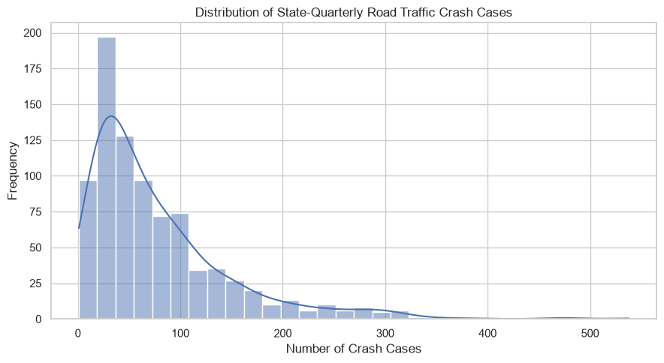
Figure 4- 1: Distribution of total road traffic crash cases across state-quarter observations, Q2 2020–Q4 2025 (author-generated).
Source: Author's calculations based on National Bureau of Statistics Road Transport Data reports (2020–2025), as referenced in Section 3.2.

National quarterly variation
National quarterly totals varied from 1,933 reported crashes in Q3 2024 to 3,617 in Q4 2022 (Figure 4.2). These are unadjusted counts rather than exposure-adjusted accident rates.
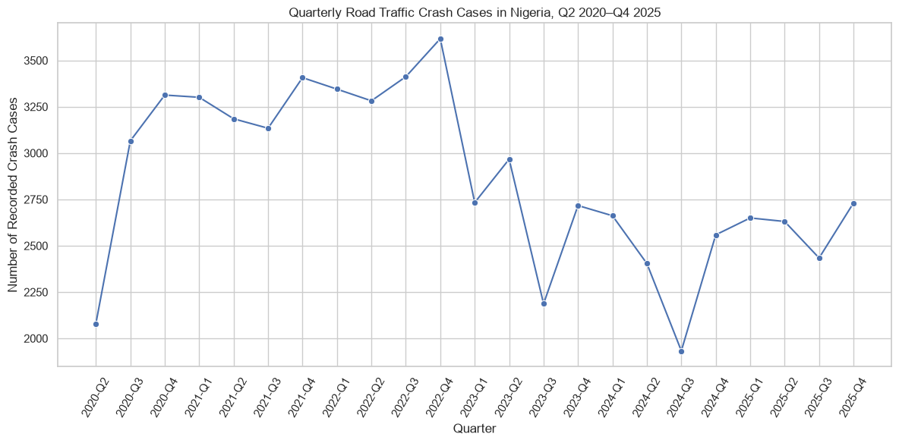
Figure 4- 2: National Quarterly Road Traffic Accident Totals, 2020–2025.
Source: Author's calculations based on National Bureau of Statistics Road Transport Data reports (2020–2025), as referenced in Section 3.2.
Q4 exceeded Q3 in all six observed years: by 8.1% in 2020, 8.7% in 2021, 6.0% in 2022, 24.2% in 2023, 32.4% in 2024 and 12.2% in 2025. However, Q1 exceeded Q4 in both 2023 and 2024. The findings therefore indicate a recurring Q3-to-Q4 increase, not a consistent annual maximum or an established seasonal cause (Figure 4.3).
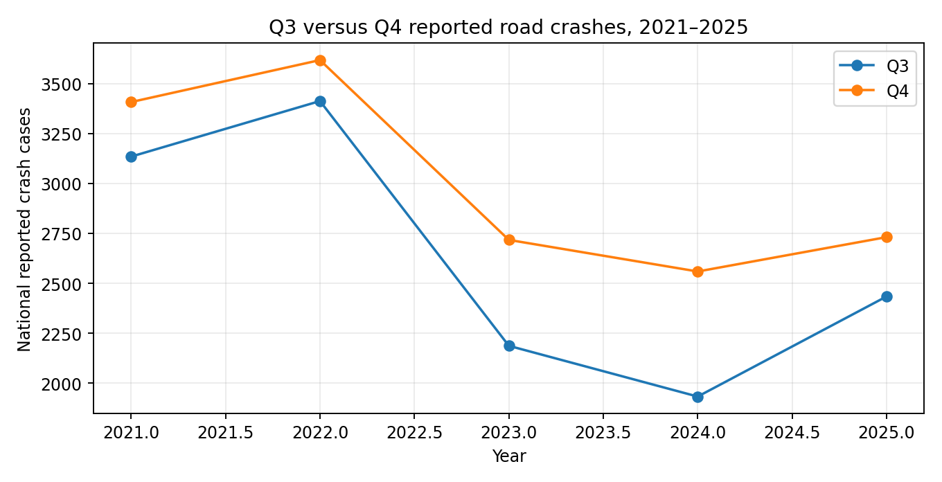
Figure 4- 3: Comparison of Q3 and Q4 Road Traffic Accident Totals, 2020–2025.
Source: Author's calculations based on National Bureau of Statistics Road Transport Data reports (2020–2025), as referenced in Section 3.2.
Table 4 - 1: National Quarterly Road Traffic Crash Counts, 2020–2025.
Quarter | National reported crashes
2020-Q2 | 2080
2020-Q3 | 3066
2020-Q4 | 3313
2021-Q1 | 3301
2021-Q2 | 3185
2021-Q3 | 3134
2021-Q4 | 3407
2022-Q1 | 3345
2022-Q2 | 3282
2022-Q3 | 3412
2022-Q4 | 3617
2023-Q1 | 2733
2023-Q2 | 2967
2023-Q3 | 2187
2023-Q4 | 2717
2024-Q1 | 2662
2024-Q2 | 2404
2024-Q3 | 1933
2024-Q4 | 2559
2025-Q1 | 2650
2025-Q2 | 2631
2025-Q3 | 2434
2025-Q4 | 2731
Source: Author's calculations based on National Bureau of Statistics Road Transport Data reports (2020–2025), as referenced in Section 3.2.
Table 4.1 provides the complete quarterly totals underlying the national trend shown in Figure 4.2.

Geographical Differences
Reported crashes varied considerably across the 37 geographical units. The highest cumulative totals were recorded in the Federal Capital Territory (6,758), Ogun (5,813), Kaduna (4,382), Nasarawa (4,057), Oyo (3,417) and Lagos (3,168).
These figures represent reported accident counts rather than rates adjusted for population, registered vehicles or distance travelled. They therefore identify geographical concentrations but do not establish comparative accident risk. The observed differences also support the inclusion of state indicators in the forecasting model to capture location-specific variation (Ziakopoulos and Yannis, 2020).
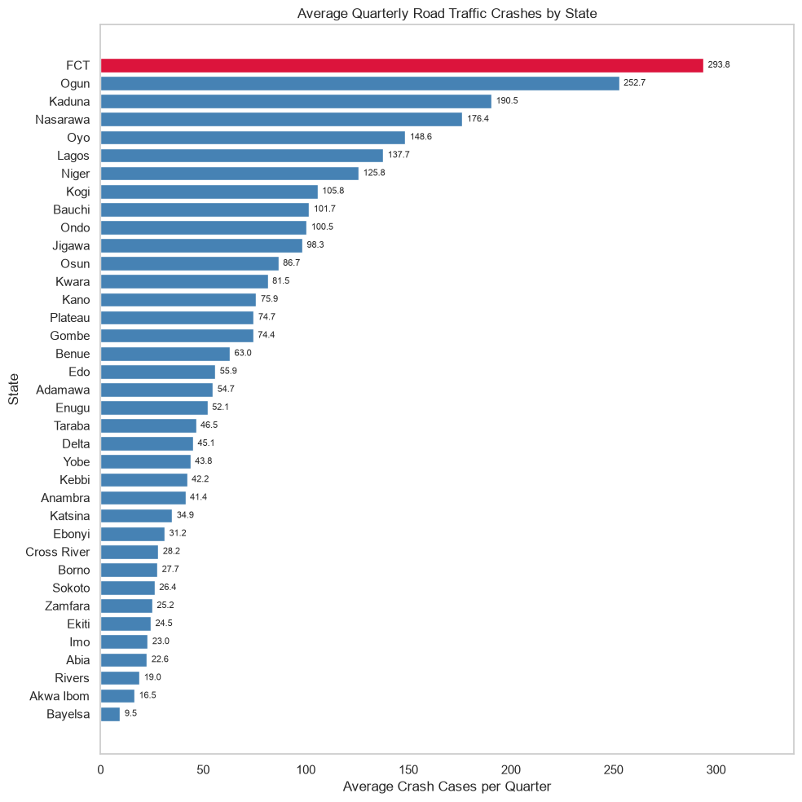
Figure 4- 4: State-level Distribution of Recorded Road Traffic Accidents.
Source: Author's calculations based on National Bureau of Statistics Road Transport Data reports (2020–2025), as referenced in Section 3.2.

Correlations and Recorded Causes
The analysis examined 18 harmonised recorded-cause categories. Categories could overlap, while additional classifications introduced in Q3 2024 were documented rather than retrospectively assigned zero values.
Recorded causes did not always follow overall crash trends. For example, speed-violation-coded counts declined from 2,586 in Q3 2022 to 1,803 in Q4 2022, although total reported crashes increased from 3,412 to 3,617. This difference does not establish a reduction in actual speeding, given uncertainties surrounding exposure and reporting practices (Figure 4.5).
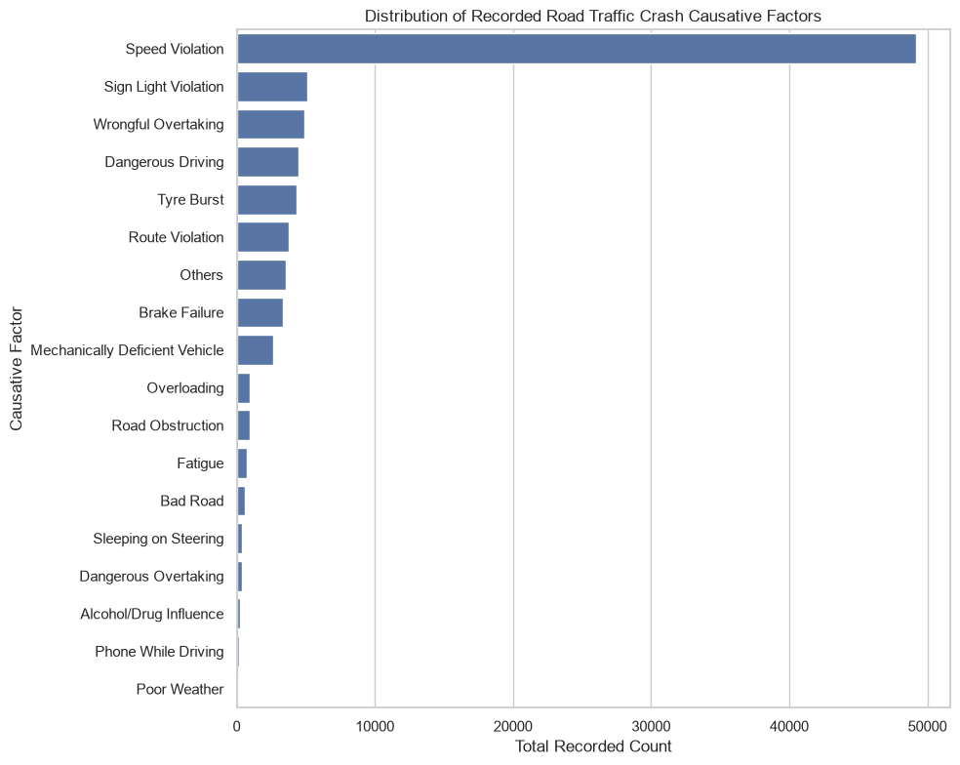
Figure 4- 5: Distribution of Recorded Road Traffic Accident Causes, 2020-2025.
Source: Author's calculations based on National Bureau of Statistics Road Transport Data reports (2020–2025), as referenced in Section 3.2.
Total crashes were strongly correlated with serious crashes (r = 0.98), people involved (r = 0.93), fatal crashes (r = 0.87) and people injured (r = 0.87). Among recorded causes, the strongest contemporaneous correlations were speed violation (r = 0.90), route violation (r = 0.79), dangerous driving (r = 0.67) and tyre burst (r = 0.67).
These associations are descriptive rather than causal. Contemporaneous accident outcomes and recorded causes were not used as same-quarter forecasting predictors. Supplementary correlation matrices are provided in Appendix B (Figures B.1 and B.2).

State-Quarter Forecasting Results
After constructing within-state historical lags, 703 observations remained for modelling. Of these, 481 were used for training through Q2 2024, 74 for validation in Q3–Q4 2024 and 148 for final testing in 2025. The selected model was refitted using all 555 pre-2025 observations.

Validation Comparison
Table 4 - 2: Comparison of baseline and machine learning model performance on the state-quarter validation set.
Approach | MAE | RMSE | R²
Previous-quarter naive | 17.800 | 27.520 | 0.721
Seasonal naive | 17.300 | 32.780 | 0.604
Historical state mean | 24.120 | 40.470 | 0.396
Linear Regression | 20.402 | 33.077 | 0.597
Random Forest (untuned) | 16.125 | 24.948 | 0.771
Gradient Boosting (untuned) | 17.962 | 27.176 | 0.728
Random Forest (tuned) | 17.583 | 24.349 | 0.781
Gradient Boosting (tuned) | 18.048 | 24.862 | 0.772
Table 4.2 compares the forecasting models and benchmarks on the validation set. The untuned Random Forest achieved the lowest MAE (16.125), while the tuned Random Forest recorded the lowest RMSE (24.349) and highest R² (0.781). Tuning therefore improved RMSE and R² but not MAE. The tuned model was selected using the validation results alongside expanding-window cross-validation evidence.

Final 2025 Holdout Results
The tuned Random Forest was evaluated on 148 held-out observations covering 37 geographical units and four quarters in 2025. It achieved an MAE of 13.081, RMSE of 18.005 and R² of 0.903, outperforming the previous-quarter naive benchmark (MAE = 14.757; RMSE = 19.982; R² = 0.881). These represent reductions of approximately 11.4% in MAE and 9.9% in RMSE (Table 4.3).
Table 4 - 3: State-Quarter Forecasting Performance: Random Forest versus Naive Benchmark, 2025.
Model | MAE | RMSE | R²
Naïve previous-quarter benchmark | 14.757 | 19.982 | 0.881
Tuned Random Forest | 13.081 | 18.005 | 0.903
The evaluation used rolling one-quarter-ahead forecasts, incorporating observed information from preceding quarters rather than generating all four 2025 forecasts at the end of 2024. Figure 4.6 compares actual and predicted values.

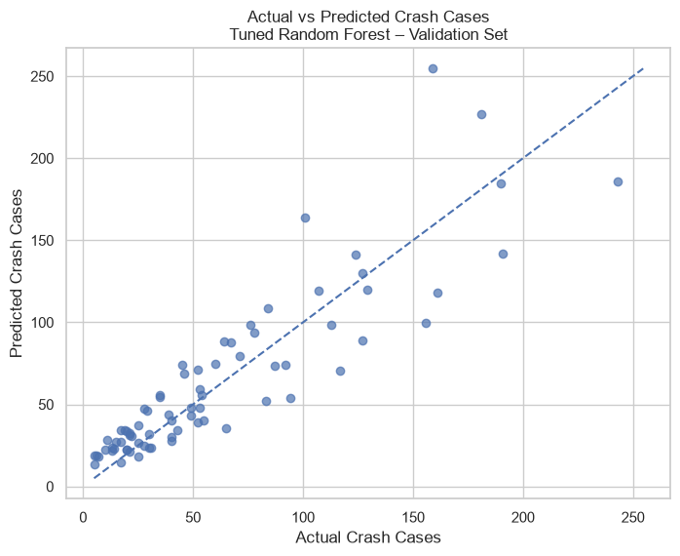
Figure 4- 6: Actual versus Predicted Crash Cases, 2025.

Supplementary residual diagnostics (Appendix D, Figures D.1 and D.2) show errors on both sides of zero, with greater dispersion at higher predicted crash counts. The results demonstrate improved accuracy over the naive benchmark for this forecasting task, although performance varies across observations.

Feature Importance
Random Forest impurity-based feature importance was concentrated in lagged crash counts (46.885%) and lagged recorded causes (45.816%), followed by state indicators (6.739%) and quarter (0.560%). However, unequal numbers of predictors across groups limit direct comparisons (Table 4.4).
Among individual recorded-cause predictors, speed violation had the highest importance (0.1068), followed by route violation (0.0644), sign/light violation (0.0496), dangerous driving (0.0385) and tyre burst (0.0357). These scores describe the model's predictive reliance on historical information, not the causal effects of the recorded factors (Breiman, 2001).
Table 4 - 4: Random Forest Feature Importance by Predictor Group.
Predictor group | Share of impurity importance
Historical total-case lags | 46.885%
Lagged recorded causes | 45.816%
State indicators | 6.739%
Quarter indicator | 0.560%

Additional Evaluation of 2025 Random Forest Errors
Although the Random Forest achieved an overall MAE of 13.081, additional analysis examined geographical, quarterly and observation-level differences in forecast accuracy. This used the same 148 held-out predictions without changing the model or evaluation procedure.

Geographical Variation in Forecast Errors
Forecast errors were assessed across all 37 geographical units, each contributing four quarterly observations. Kwara recorded the lowest MAE (4.419), followed by Bayelsa and Abia, while the Federal Capital Territory recorded the highest (37.231), followed by Nasarawa and Ogun (Table 4.5; Figure 4.7).
These differences demonstrate that aggregate accuracy does not imply uniform performance. Higher absolute errors may partly reflect larger reported crash volumes, while the four observations per unit limit generalisation.

Table 4 - 5: Five Geographical Units with the Lowest and Highest Random Forest Forecast Errors in 2025.
Error group | Geographical unit | MAE | RMSE
Lowest | Kwara | 4.419 | 5.383
Lowest | Bayelsa | 4.979 | 5.109
Lowest | Abia | 5.029 | 5.828
Lowest | Cross River | 5.675 | 7.073
Lowest | Yobe | 6.072 | 6.543
Highest | FCT | 37.231 | 42.624
Highest | Nasarawa | 28.573 | 37.574
Highest | Ogun | 26.562 | 35.009
Highest | Kaduna | 26.366 | 33.918
Highest | Kano | 21.953 | 25.244
Source: Author's calculations using the 2025 Random Forest test predictions.
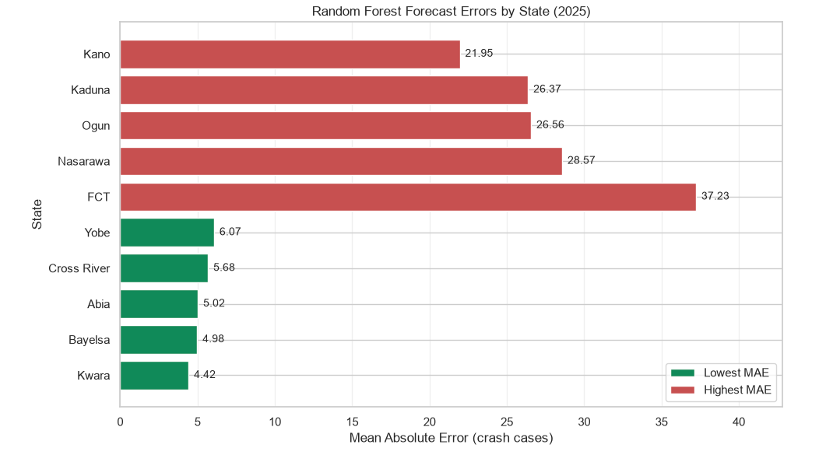
Figure 4- 7: Five Geographical Units with the Lowest and Highest Random Forest Mean Absolute Errors in 2025.

Quarterly Variation in Forecast Errors
Each quarter contained 37 observations. MAE declined from 14.105 in Q1 to 12.475 in Q4, an improvement of approximately 11.6%. RMSE similarly decreased from 20.086 to 15.343 (Table 4.6; Figure 4.8).
Although errors were lower towards the end of 2025, this single-year pattern does not establish sustained improvement in forecasting accuracy.
Table 4 - 6: Quarterly Random Forest Forecast Errors, 2025
Quarter | Observations | MAE | RMSE
Q1 | 37 | 14.105 | 20.086
Q2 | 37 | 13.184 | 19.972
Q3 | 37 | 12.562 | 16.095
Q4 | 37 | 12.475 | 15.343
Source: Author's calculations using the 2025 Random Forest test predictions.
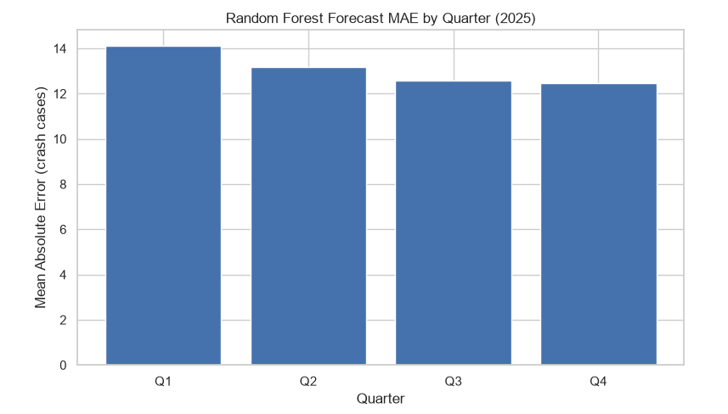
Figure 4- 8: Quarterly Mean Absolute Error of the Random Forest Model, 2025

Distribution of Absolute Forecast Errors
Across the 148 predictions, median absolute error was 9.395, compared with an MAE of 13.081. The middle 50% of absolute errors ranged from 4.916 to 16.934, with an interquartile range of 12.018. The maximum error reached 69.892 (Table 4.7).
The difference between the median and maximum indicates that relatively large errors occurred in a smaller subset of predictions, highlighting limitations of aggregate accuracy measures.
Table 4 - 7: Distribution of Random Forest Absolute Forecast Errors, 2025.
Metric | Crash cases
Mean absolute error | 13.081
Median absolute error | 9.395
25th percentile | 4.916
75th percentile | 16.934
Interquartile range | 12.018
Maximum absolute error | 69.892
Source: Author's calculations using the 2025 Random Forest test predictions.

Residual Diagnostics
Residuals were calculated as actual minus predicted crash counts; positive values indicate underprediction and negative values indicate overprediction.
Figure 4.9 shows residuals on both sides of zero, with greater dispersion at higher predicted crash counts. This suggests possible heteroscedasticity, although the visual pattern does not establish a formal statistical relationship.
Quarterly residual distributions also varied (Figure 4.10). Median residuals were slightly positive in Q1 and Q2, negative in Q3 and close to zero in Q4. More pronounced outliers appeared in the earlier quarters, consistent with the higher quarterly MAE and RMSE. However, residuals near zero do not necessarily indicate small individual errors.
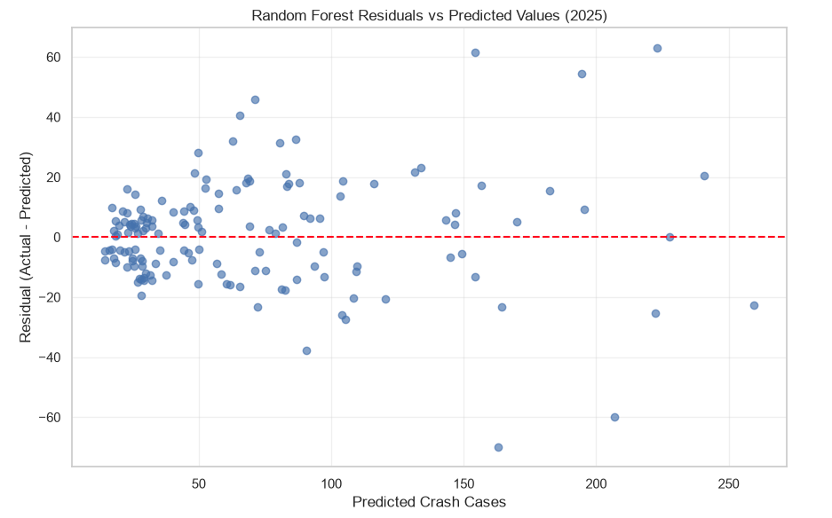
Figure 4- 9: Random Forest Residuals Versus Predicted Crash Counts, 2025.

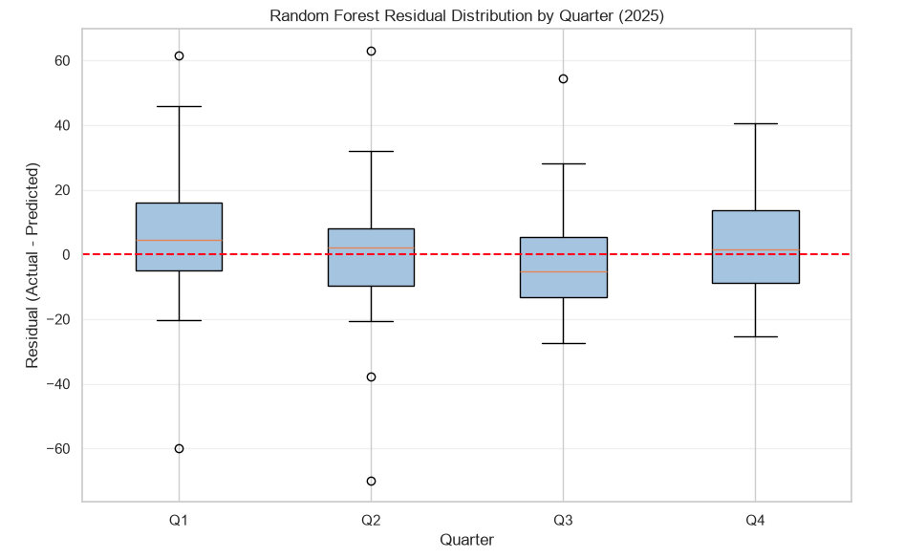
Figure 4- 10: Random Forest Residual Distribution by Quarter, 2025.

Summary of Additional Error Analysis
The additional analysis identified geographical differences, declining quarterly errors and occasional large prediction deviations. Overall, the Random Forest performed better than the naive benchmark, but its accuracy was not uniform across states, quarters or crash-count magnitudes.

National Annual Forecasting and Sanusi Comparison
The national annual dataset contains 65 observations (1960–2024), with minor, serious, fatal and total accident counts forecast separately. The analysis first examines the reproducibility and retrospective accuracy of forecasts published by Sanusi, Adebola and Adegoke (2016), then compares forecasting methods using 11 expanding-window, one-year-ahead predictions for 2014–2024. Unlike the original fixed-origin projections, these rolling forecasts incorporate newly available annual observations.

Reproduction and Retrospective Evaluation of Sanusi's Forecasts
The published ARIMA (1,1,1) specification for total crashes was fitted using observations from 1960–2011. The reproduced forecasts for 2012 and 2013 were 12,969.13 and 13,122.95, compared with the published values of 12,962.39 and 13,146.40. Differences of 6.74 and 23.45 crashes indicate close approximation rather than exact replication.
Against observed 2012–2013 counts, the reproduced forecasts achieved an MAE of 376.46 and RMSE of 385.63, compared with 368.11 and 374.42 for the published forecasts. Historical FRSC data revisions limit conclusions about exact reproducibility.
Models fitted through 2011 reproduced the published 2014–2020 forecasts more closely than models refitted through 2013 for total crashes (MAE 16.77 versus 453.88), serious crashes (106.53 versus 629.82) and fatal crashes (2.23 versus 426.54). Minor-crash forecasts showed the opposite pattern (7.95 for the 2013 fit versus 271.13 for the 2011 fit). No single tested estimation window therefore reproduced the published projections most closely across all categories. Differences in data versions or estimation settings may also explain the discrepancies.
The published 2014–2020 forecasts were subsequently compared with observed FRSC counts (Table 4.8). Fatal-crash forecasts had the lowest MAPE (6.23%), followed by total crashes (27.98%), while minor crashes had the highest (54.50%). Errors did not consistently increase with the forecast horizon. This retrospective assessment is distinct from the expanding-window evaluation conducted for 2014–2024.
Table 4 - 8: Retrospective Accuracy of Sanusi's Published Forecasts Against Observed FRSC Crash Counts, 2014–2020
Accident category | MAE | RMSE | MAPE (%)
Minor | 579.51 | 616.31 | 54.50
Serious | 1,624.03 | 1,767.67 | 27.43
Fatal | 182.29 | 221.49 | 6.23
Total | 2,790.83 | 2,915.91 | 27.98

Comparable Model Accuracy, 2014-2024
Five forecasting approaches were evaluated using 11 expanding-window, one-year-ahead forecasts from 2014 to 2024. Each model was assessed against the same observed outcomes within each accident category, ensuring a consistent evaluation period.
Figure 4.11 presents the historical national accident series used in the annual analysis, illustrating variation in reported crash counts across severity categories over time. This historical variation provides context for the forecasting exercise and highlights the challenge of predicting accident counts from past observations. The figure is descriptive and does not independently establish the accuracy of any forecasting model.
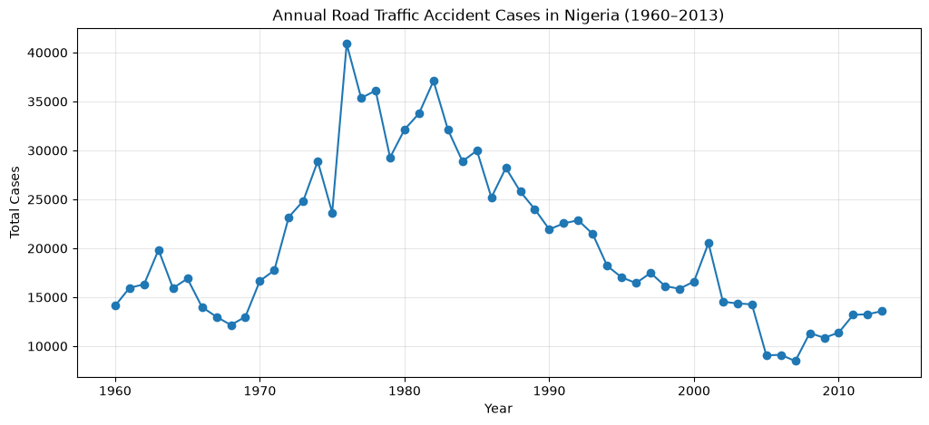
Figure 4- 11: Historical annual national accident cases, 1960-2013.
Tables 4.9–4.12 report forecasting performance by accident category. Gradient Boosting achieved the lowest fatal-crash MAE (149.50), while the naive previous-year benchmark recorded the lowest MAE for minor (238.27), serious (859.27) and total crashes (1,141.73).
For fatal crashes, Gradient Boosting performed best across MAE, RMSE and MAPE; for minor crashes, the naive benchmark led across all three. The preferred model differed by metric for serious and total crashes. The naive benchmark achieved the lowest MAE and MAPE, while Random Forest recorded the lowest serious-crash RMSE (995.27) and Gradient Boosting the lowest total-crash RMSE (1,330.91).

Table 4 - 9: National Annual Forecasting Model Performance for Fatal Crashes, 2014–2024.
Model | MAE | RMSE | MAPE (%)
Gradient Boosting | 149.50 | 179.00 | 5.26
Random Forest | 214.80 | 243.39 | 7.39
Naive previous-year | 200.55 | 256.22 | 7.13
Sanusi ARIMA(0,1,1) | 237.90 | 278.98 | 8.54
Linear Regression | 276.81 | 354.12 | 10.09

Table 4 - 10: National Annual Forecasting Model Performance for Minor Crashes, 2014–2024.
Model | MAE | RMSE | MAPE (%)
Naive previous-year | 238.27 | 330.69 | 21.64
Sanusi ARIMA(1,1,1) | 278.16 | 377.32 | 25.92
Random Forest | 409.82 | 540.51 | 41.27
Gradient Boosting | 438.28 | 594.22 | 44.69
Linear Regression | 574.19 | 636.58 | 46.08

Table 4 - 11: National Annual Forecasting Model Performance for Serious Crashes, 2014–2024.
Model | MAE | RMSE | MAPE (%)
Naive previous-year | 859.27 | 1074.92 | 12.72
Random Forest | 891.78 | 995.27 | 13.12
Gradient Boosting | 998.80 | 1137.27 | 14.90
Sanusi ARIMA(1,1,0) | 1045.35 | 1182.92 | 15.55
Linear Regression | 1091.25 | 1201.73 | 16.07

Table 4 - 12: National Annual Forecasting Model Performance for Total Crashes, 2014–2024.
Model | MAE | RMSE | MAPE (%)
Naive previous-year | 1141.73 | 1518.79 | 10.61
Gradient Boosting | 1209.94 | 1330.91 | 11.51
Random Forest | 1259.58 | 1338.69 | 11.77
Sanusi ARIMA(1,1,1) | 1326.17 | 1621.46 | 12.41
Linear Regression | 1541.79 | 1681.11 | 13.97

Table 4 - 13: Best-Performing National Annual Forecasting Models by Accident Category, 2014–2024.
Accident Category | Best Model by MAE | MAE | Best Model by RMSE | RMSE
Fatal | Gradient Boosting | 149.50 | Gradient Boosting | 179.00
Serious | Naive | 859.27 | Random Forest | 995.27
Minor | Naive | 238.27 | Naive | 330.69
Total | Naive | 1,141.73 | Gradient Boosting | 1,330.91
Table 4.13 summarises the best-performing models. Overall, no approach consistently outperformed the others across accident categories and metrics. The naive benchmark remained competitive, achieving the lowest MAE in three of four categories. However, the limited evaluation period means that individual years may influence model rankings, particularly under RMSE. Year-by-year absolute errors are presented in Appendix C (Figures C.1–C.4).

Updated ARIMA Sensitivity Analysis
The annual analysis also compares published Sanusi ARIMA orders with updated alternatives identified using the extended historical data. The alternative ARIMA specifications were investigated using stationarity diagnostics and information criteria calculated from the extended historical series.
This comparison illustrates the sensitivity of annual forecasting results to ARIMA model specification and highlights the importance of reassessing historical model choices when additional observations become available.
Because this exploratory model-identification process incorporated observations from the subsequent 2014–2024 evaluation period, the sensitivity results should not be interpreted as an entirely independent prospective assessment of model selection. Instead, they indicate how alternative specifications perform under the same expanding-window forecasting procedure, while recognising the possibility of retrospective selection bias. The fatal-case specification remained ARIMA (0,1,1).

Synthesis of Results
Across the two analyses, historical accident information provided a strong forecasting baseline. The naive previous-year approach remained competitive for several annual outcomes, whereas the tuned Random Forest improved upon the previous-quarter benchmark in the state-quarter holdout. These results concern different forecasting tasks and are not directly comparable in raw error units.
The geographical and quarterly results provide additional detail beyond the annual series. Their possible explanations and implications for road-safety planning are discussed in Chapter Five.

Chapter 5 - Discussion

Overview and Interpretation of Research Findings
This chapter interprets the findings in relation to the research objectives and Nigerian road-safety context, drawing on the national annual and state-quarter analyses presented in Chapter 4.
The discussion focuses on three themes: the persistence of historical accident counts, the predictive contribution of state-quarter information, and recurring Q3-to-Q4 increases in reported crashes. It also considers methodological limitations and implications for road-safety planning.

Historical Persistence and the Annual Forecasting Comparison
The national annual analysis extends the forecasting framework of Sanusi, Adebola and Adegoke (2016), examining both the reproducibility and retrospective accuracy of their published ARIMA forecasts. The close correspondence between the reproduced and published 2012–2013 forecasts suggests that the original approach could be approximated using available FRSC records. However, revisions to historical data, particularly for 2010–2012, complicate exact replication and highlight the importance of documenting dataset versions.
Alternative estimation windows reproduced the published 2014–2020 projections with differing accuracy. Models fitted through 2011 more closely approximated total, serious and fatal-crash forecasts, whereas the 2013 estimation window performed better for minor crashes. These findings raise questions about reproducibility but do not establish the original estimation window, since data revisions, estimation settings and other methodological differences may explain the discrepancies.
Retrospective comparison with observed FRSC records also revealed limitations in fixed-origin, multi-year projections. Published fatal-crash forecasts exhibited relatively low percentage errors, while other categories showed greater deviations. Accuracy over a short validation period may therefore not persist across longer forecasting horizons, particularly when accident patterns or reporting practices change.
In the 2014–2024 expanding-window evaluation, model rankings differed across accident categories and accuracy metrics. Gradient Boosting performed best for fatal crashes, while the previous-year naive benchmark remained competitive for minor, serious and total crashes. Differences between MAE and RMSE rankings demonstrate the importance of considering both typical errors and larger deviations when selecting forecasting methods (Hyndman and Koehler, 2006).
The naive benchmark's performance suggests persistence in aggregate reported accident counts, with the preceding year's observation providing a useful forecasting reference. However, this does not establish stationarity or unchanged road-safety conditions. Limited annual observations and lag-based predictors may have restricted the additional information available to more complex models. Consequently, the findings do not demonstrate consistent superiority of machine learning over simpler forecasting approaches.
The updated ARIMA sensitivity analysis further indicates that performance depends on model specification. Because alternative orders were investigated using extended historical data that included the evaluation period, these findings remain exploratory and subject to possible model-selection look-ahead bias.
Finally, the 11-year evaluation period limits confidence in long-term model rankings, while historical FRSC revisions introduce additional uncertainty. Future prospective evaluation, using newly observed records and model selection restricted to information available at each forecast origin, would provide stronger evidence of forecasting stability.

State-Quarter Forecasting and the Role of Recorded Causes
The tuned Random Forest improved 2025 state-quarter forecasting accuracy relative to the previous-quarter naive benchmark, reducing MAE by approximately 11.4%. This demonstrates an incremental predictive benefit within the evaluated dataset, although its stability under changing reporting practices and road conditions requires further testing (Breiman, 2001).
The improvement was achieved using rolling one-quarter-ahead forecasts, incorporating observations from the preceding quarter. Its operational usefulness therefore depends on the timely availability and consistency of reported accident data.
Despite stronger aggregate accuracy, forecast errors varied considerably across geographical units, particularly in the Federal Capital Territory, Nasarawa and Ogun. Residuals also showed greater dispersion at higher predicted crash counts. These findings indicate that overall performance metrics can conceal differences between individual predictions and locations (Hyndman and Koehler, 2006). However, larger absolute errors do not necessarily imply poorer relative accuracy or greater underlying accident risk, especially where traffic exposure and reported crash volumes differ (Lord and Mannering, 2010).
Lagged crash counts and recorded causes were the dominant predictor groups, with speed violation the highest-ranked individual recorded cause. This is consistent with Nigerian research identifying speeding, overtaking, vehicle defects and road conditions among reported crash-related factors (Adeoye et al., 2014; Anebonam et al., 2019). Etika, Merat and Carsten (2021) also identify competing motivations influencing commercial drivers' speeding behaviour.
Nevertheless, the model uses aggregated administrative classifications rather than directly measured driving behaviour. Correlated predictors, unequal feature-group sizes and impurity-based importance calculations complicate interpretation (Strobl et al., 2008). The importance assigned to speed violation therefore indicates predictive information, not evidence of its causal effect on accident counts.
Overall, the results support the potential value of historical crash and recorded-cause information for short-term forecasting. Practical applications should nevertheless account for geographical variation in model accuracy, limitations in accident reporting and the need for prospective validation.

Quarterly Patterns and Possible Explanations for Q4 Increases
The recurring Q3-to-Q4 increase reflects reported accident counts rather than exposure-adjusted risk. Without traffic-volume or vehicle-distance data, the analysis cannot establish whether the increase results from more journeys, higher risk per journey or changes in reporting (Lord and Mannering, 2010).
Increased travel and commercial transport activity during year-end festivities provide plausible explanations. The FRSC's 'Ember Months' awareness campaigns demonstrate institutional concern about road safety during this period (FRSC, 2024a). However, the dataset contains no direct measures of travel exposure, and the campaign documentation does not establish the causes of the observed quarterly increases.
Recorded speed violations also show inconsistent patterns. In 2022, speed-violation counts declined from 2,586 in Q3 to 1,803 in Q4, despite total crashes increasing from 3,412 to 3,617. Conversely, in 2024, speed-violation counts rose from 1,119 to 2,165 alongside an increase in total crashes from 1,933 to 2,559. These differences caution against attributing the Q4 pattern solely to speeding. Recorded causes may also overlap, and reporting practices can affect their classification.
Weather, road conditions, enforcement and economic activity remain possible explanations but were not directly tested. The quarter indicator's low Random Forest importance (0.560%) does not disprove seasonality, as lagged predictors may capture recurring patterns. Furthermore, only five complete years were available. Longer time series, exposure-adjusted measures and explicit seasonal modelling would be required to establish the pattern's stability and underlying mechanisms.

Linking the Two Analyses to Nigerian Road-Safety Policy
The analyses support complementary levels of monitoring: annual national indicators for longer-term review and quarterly state-level forecasts for identifying places or periods warranting closer examination. This is an operational use of prediction rather than an estimate of policy effects.
The annual and state-quarter findings together suggest that persistent historical counts can be complemented by more detailed location and recorded-cause information. Quarterly variation, including the Q3-to-Q4 pattern, would be obscured by national annual totals.
The Nigerian policy setting helps interpret why these predictive patterns matter. The Federal Road Safety Commission (Establishment) Act 2007 and National Road Traffic Regulations 2012 establish regulatory powers and requirements addressing speed, driver behaviour and vehicle safety (Federal Republic of Nigeria, 2007; Federal Republic of Nigeria, 2012). The Nigeria Road Safety Strategy 2016–2020 frames road safety as a coordinated issue involving road users, vehicles, roads and institutions (FRSC, 2016). Infrastructure-related interventions, including the World Bank-supported Federal Roads Development Project, similarly reflect a combination of engineering, enforcement and public education (World Bank, 2008).
Speed management provides a specific thematic bridge. The FRSC’s 2022 annual reporting and later public statements identify speed-related crashes as an ongoing concern (FRSC, 2022; FRSC, 2023). Its speed-limiting-device programme and associated implementation challenges, including reported tampering and technical constraints, indicate that policy design and implementation are distinct questions (FRSC, 2024). The state-quarter model’s emphasis on lagged speed violations is consistent with speed as a relevant operational monitoring variable, but it does not show that speed-limiting policies caused changes in observed crash counts.
A potential application is regularly updated state-quarter forecasts to support monitoring and preparedness. Implementation would require validation of incoming records, prospective performance checks and separate evaluation of any interventions informed by the forecasts.

Limitations, Implications and Synthesis
The study's contribution lies in comparing accident forecasting approaches across complementary temporal and geographical scales while explicitly considering the information available at each forecast origin.
Table 5.1 summarises the principal limitations of the datasets, forecasting procedures and model interpretation, alongside their implications and priorities for future research.
Table 5 - 1: Summary of Methodological Limitations and Implications for the Study.
Limitation | Implication for the findings | Recommended consideration
Administrative reporting and data quality | Changes in reporting completeness, case definitions and recording practices may affect the consistency of observed accident trends across locations and periods. | Interpret forecasts as predictions of reported crashes and strengthen data validation and standardisation.
Limited annual observations | The national annual dataset contains 65 observations, with only 11 one-year-ahead evaluation periods, making model rankings sensitive to a small number of forecasting errors. | Extend the evaluation period where possible and continue comparing complex models against simple benchmarks.
Short state-quarter time series | The state-quarter dataset covers 23 quarters, restricting the assessment of longer-term seasonal patterns and model stability. | Evaluate the models over additional years as new quarterly observations become available.
Rolling one-quarter-ahead evaluation | The 2025 predictions use observed preceding-quarter information as it becomes available. Performance therefore does not represent a full-year forecast issued at the end of 2024. | Distinguish rolling forecasts from fixed-origin forecasts when interpreting or applying the results.
Absence of traffic-exposure measures | Differences in reported crash counts cannot independently establish differences in crash rates or individual road-user risk. | Incorporate traffic volumes, vehicle-distance measures or other appropriate exposure indicators in future analyses.
Recorded causative-factor classifications | Recorded causes may overlap or reflect administrative coding practices, limiting their interpretation as independent crash determinants. | Treat causative-factor variables as predictive indicators rather than evidence of causal relationships.
Feature-importance methodology | Impurity-based Random Forest importance can be affected by correlated predictors and differences in the number of encoded features. | Interpret importance rankings cautiously and consider alternative methods, such as permutation importance.
Differences between forecasting tasks | National annual and state-quarter forecasts use different observational units, horizons and target scales, preventing direct comparison of raw MAE and RMSE values. | Evaluate model performance within each forecasting task using appropriate benchmarks.
Source: Author's synthesis of the study's methodological design and evaluation findings.
These limitations restrict generalisation beyond the observed periods and prevent predictions from being interpreted as causal estimates or exposure-adjusted accident risks. Forecasts should therefore complement improvements in data quality and independent evaluation of road-safety interventions (Lord and Mannering, 2010).
Overall, the findings demonstrate the predictive value of historical accident information at both national and state-quarter levels. While more complex models did not consistently outperform simple benchmarks in the annual analysis, the state-quarter Random Forest achieved measurable improvements in short-term forecasting accuracy. Geographical differences and recurring Q3-to-Q4 increases also highlight areas requiring further investigation. Together, these findings contribute to a more geographically and temporally informed approach to road-safety monitoring in Nigeria, while recognising the limitations of administrative data and the absence of exposure-adjusted measures.

Chapter 6 - Conclusions and Recommendations

Introduction
This chapter presents the study's conclusions in relation to the research objectives, followed by practical recommendations, limitations and directions for future research.

Conclusions in Relation to the Research Objectives
Regarding the first research question, the historical analysis identified temporal and geographical variation in recorded road traffic accidents. The national annual series provided a long-term perspective on total, fatal, serious and minor crashes, while the state-quarter dataset revealed differences between states and within years. Reported crash counts increased from Q3 to Q4 in every year examined, although Q4 was not always the highest-count quarter. These findings support geographically targeted monitoring but, without traffic-exposure measures, cannot establish changes in crash risk per journey or vehicle-kilometre.
For the second research question, forecasting performance varied by accident category, data frequency and evaluation metric. In the annual comparisons, the previous-year naive benchmark achieved the lowest MAE for several categories, while Gradient Boosting and Random Forest performed better on selected measures. At the state-quarter level, the tuned Random Forest achieved a 2025 test MAE of 13.081, RMSE of 18.005 and R² of 0.903, reducing MAE by approximately 11.4% relative to the previous-quarter benchmark. This improvement applies to rolling one-quarter-ahead forecasts using the latest observed quarterly information, rather than a fixed-origin forecast for all four quarters of 2025. The findings therefore support selecting forecasting methods according to the specific task and evaluating them against simple benchmarks.
For the third research question, lagged crash counts and recorded-cause variables provided substantial predictive information, with state identity contributing additional information. Speed violation was prominent among individual recorded-cause predictors. However, feature importance reflects predictive association within the fitted model, not the causal effects of speeding or other factors. Historical accident information may therefore support monitoring and the identification of emerging patterns, while enforcement decisions require supporting evidence and independent evaluation.
Together, the findings address the three research questions through complementary descriptive and predictive analyses, providing a basis for evidence-informed road-safety monitoring without making unsupported causal claims.

Practical Recommendations
First, Nigerian road-safety institutions should evaluate short-horizon forecasting tools as a complement to existing monitoring and planning. Regularly updated state-quarter predictions could identify locations requiring closer examination or operational preparation, provided their accuracy is assessed against newly reported outcomes.
Second, accident-data collection should prioritise consistent state-level reporting, stable definitions of recorded causes and transparent documentation of classification changes. Improved longitudinal data would strengthen regional and seasonal comparisons and support more reliable crash-frequency analysis (Lord and Mannering, 2010).
Third, the recurring Q3-to-Q4 increase warrants closer monitoring of travel demand, enforcement activity and crash circumstances during year-end periods. Increased crash counts should not automatically be interpreted as increased risk per journey. Interventions should be evaluated using appropriate traffic-exposure measures and credible comparison designs (Lord and Mannering, 2010).
Fourth, forecasting outputs should include uncertainty estimates and comparisons with simple benchmarks. More complex models should be adopted only when they demonstrate meaningful and sustained improvements over simpler alternatives (Hyndman and Athanasopoulos, 2021; Hyndman and Koehler, 2006).

Study Limitations
The principal limitations include inconsistencies in historical administrative records, the small annual evaluation sample, the rolling state-quarter forecasting design and the absence of traffic-exposure measures. These limitations are examined in Section 5.6 and Table 5.1.
Consequently, the findings apply to the specified forecasting tasks and should not be interpreted as estimates of exposure-adjusted crash risk or causal policy effects.

Directions for Future Research
Future research could extend the state-quarter series, assess prospective model stability and explore spatial or hierarchical forecasting methods that account for relationships between states. Additional predictors could include traffic volumes, road conditions, weather, public holidays, economic indicators and enforcement activity, provided they are available before the forecast period. Studies could also examine permutation importance and quantify forecast uncertainty.
Evaluating whether road-safety interventions reduce crashes would require a separate causal research design, incorporating clearly dated interventions, appropriate comparison groups and traffic-exposure measures. Such research would complement the predictive objectives of this study.

Final Statement
This study demonstrates the value of historical accident information for forecasting reported road traffic crashes in Nigeria, while showing that the benefits of machine-learning complexity depend on the dataset and forecasting task. Its principal contribution is a transparent comparison of national annual forecasting methods alongside a more geographically detailed state-quarter prediction framework. The findings support evidence-informed road-safety monitoring, continued improvements in data quality and independent evaluation of interventions.

References
Adejugbagbe, A.M., Fatiregun, A.A., Rukewe, A. and Alonge, T. (2015) ‘Epidemiology of road traffic crashes among long distance drivers in Ibadan, Nigeria’, African Health Sciences, 15(2), pp. 480–488. https://doi.org/10.4314/ahs.v15i2.22.
Adeoye, P.O., Kadri, D.M., Bello, J.O., Ofoegbu, C.K.P., Abdur-Rahman, L.O., Adekanye, A.O. and Solagberu, B.A. (2014) ‘Host, vehicular and environmental factors responsible for road traffic crashes in a Nigerian city: identifiable issues for road traffic injury control’, Pan African Medical Journal, 19, Article 159. https://doi.org/10.11604/pamj.2014.19.159.5017.
Anebonam, U., Okoli, C., Ossai, P., Ilesanmi, O., Nguku, P., Nsubuga, P., Abubakar, A. and Oyemakinde, A. (2019) ‘Trends in road traffic accidents in Anambra State, South Eastern Nigeria: need for targeted sensitization on safe roads’, Pan African Medical Journal, 32(Suppl. 1), Article 12. https://doi.org/10.11604/pamj.supp.2019.32.1.13285.
Aptel, I., Salmi, L.R., Masson, F., Bourdé, A., Henrion, G. and Erny, P. (1999) ‘Road accident statistics: discrepancies between police and hospital data in a French island’, Accident Analysis & Prevention, 31(1–2), pp. 101–108. https://doi.org/10.1016/S0001-4575(98)00051-7.
Bergmeir, C., Hyndman, R.J. and Koo, B. (2018) ‘A note on the validity of cross-validation for evaluating autoregressive time series prediction’, Computational Statistics & Data Analysis, 120, pp. 70–83. https://doi.org/10.1016/j.csda.2017.11.003.
Breiman, L. (2001) ‘Random forests’, Machine Learning, 45, pp. 5–32. https://doi.org/10.1023/A:1010933404324.
Chang, L.-Y. and Wang, H.-W. (2006) ‘Analysis of traffic injury severity: an application of non-parametric classification tree techniques’, Accident Analysis & Prevention, 38(5), pp. 1019–1027. https://doi.org/10.1016/j.aap.2006.04.009.
Etika, A., Merat, N. and Carsten, O. (2021) ‘Identifying salient beliefs underlying speeding behaviour: an elicitation study of Nigerian drivers’, Transportation Research Interdisciplinary Perspectives, 9, Article 100279. https://doi.org/10.1016/j.trip.2020.100279.
Federal Republic of Nigeria (2007) Federal Road Safety Commission (Establishment) Act 2007, No. 22. Available at: https://frsc.gov.ng/FRSCACT2007.pdf (Accessed: 29 September 2026).
Federal Republic of Nigeria (2012) National Road Traffic Regulations 2012. Available at: https://frsc.gov.ng/NATROADTRAFFICREGS2012.pdf (Accessed: 29 September 2026).
Federal Road Safety Corps (FRSC) (2016) Nigeria Road Safety Strategy (NRSS) 2016–2020. Available at: https://frsc.gov.ng/NRSSSeries1.pdf (Accessed: 29 September 2026).
Federal Road Safety Corps (FRSC) (2022) 2022 Annual Report. Available at: https://staging.frsc.gov.ng/frsc-admin/uploads/2022_ANNUAL_REPORT_1_14_compressed_8279ef83c7.pdf (Accessed: 29 September 2026).
Federal Road Safety Corps (FRSC) (2023) ‘FRSC gears up towards the development and implementation of new policy on pre-fitted speed limiting device on locally assembled and imported vehicles’, 11 October. Available at: https://frsc.gov.ng/frsc-gears-up-towards-the-development-and-implementation-of-new-policy-on-pre-fitted-speed-limiting-device-on-locally-assembled-and-imported-vehicles/ (Accessed: 29 September 2026).
Federal Road Safety Corps (FRSC) (2024a) ARC Compendium 2024. Available at: https://frsc.gov.ng/wp-content/uploads/2024/08/ARC-COMPENDIUM-20241.pdf (Accessed: 29 September 2026).
Federal Road Safety Corps (FRSC) (2024b) ‘FRSC Corps Marshal flags-off Ember Months campaign, harps on aggressive sensitisation of commuters to speak up against reckless driving’, 1 November. Available at: https://frsc.gov.ng/frsc-corps-marshal-flags-off-ember-months-campaign-harps-on-aggressive-sensitisation-of-commuters-to-speak-up-against-reckless-driving/ (Accessed: 29 September 2026).
Friedman, J.H. (2001) ‘Greedy function approximation: a gradient boosting machine’, The Annals of Statistics, 29(5), pp. 1189–1232. https://doi.org/10.1214/aos/1013203451.
Gebru, T., Morgenstern, J., Vecchione, B., Vaughan, J.W., Wallach, H., Daumé III, H. and Crawford, K. (2021) ‘Datasheets for datasets’, Communications of the ACM, 64(12), pp. 86–92. https://doi.org/10.1145/3458723.
Hyndman, R.J. and Athanasopoulos, G. (2021) Forecasting: Principles and Practice. 3rd edn. Melbourne: OTexts. Available at: https://otexts.com/fpp3/ (Accessed: 9 November 2026).
Hyndman, R.J. and Koehler, A.B. (2006) ‘Another look at measures of forecast accuracy’, International Journal of Forecasting, 22(4), pp. 679–688. https://doi.org/10.1016/j.ijforecast.2006.03.001.
James, G., Witten, D., Hastie, T. and Tibshirani, R. (2021) An Introduction to Statistical Learning: With Applications in R. 2nd edn. New York: Springer. https://doi.org/10.1007/978-1-0716-1418-1.
Kotu, V. and Deshpande, B. (2019) Data Science: Concepts and Practice. 2nd edn. Morgan Kaufmann. ISBN 9780128147610.
Lord, D. and Mannering, F. (2010) ‘The statistical analysis of crash-frequency data: a review and assessment of methodological alternatives’, Transportation Research Part A: Policy and Practice, 44(5), pp. 291–305. https://doi.org/10.1016/j.tra.2010.02.001.
Mannering, F.L. and Bhat, C.R. (2014) ‘Analytic methods in accident research: methodological frontier and future directions’, Analytic Methods in Accident Research, 1, pp. 1–22. https://doi.org/10.1016/j.amar.2013.09.001.
National Bureau of Statistics (2020a) Road Transport Data (Q2 2020). Available at: https://www.nigerianstat.gov.ng/elibrary/read/1164 (Accessed: 27 August 2026).
National Bureau of Statistics (2020b) Road Transport Data (Q3 2020). Available at: https://www.nigerianstat.gov.ng/elibrary/read/1209 (Accessed: 27 August 2026).
National Bureau of Statistics (2020c, 2021a) Road Transport Data (Q4 2020, Q1 & Q2 2021). Available at: https://www.nigerianstat.gov.ng/elibrary/read/1241112 (Accessed: 27 August 2026).
National Bureau of Statistics (2021b) Road Transport Data (Q3 & Q4 2021). Available at: https://www.nigerianstat.gov.ng/elibrary/read/1241145 (Accessed: 27 August 2026).
National Bureau of Statistics (2022a) Road Transport Data (Q1 2022). Available at: https://www.nigerianstat.gov.ng/elibrary/read/1241182 (Accessed: 27 August 2026).
National Bureau of Statistics (2022b) Road Transport Data (Q2 2022). Available at: https://www.nigerianstat.gov.ng/elibrary/read/1241251 (Accessed: 27 August 2026).
National Bureau of Statistics (2022c) Road Transport Data (Q3 2022). Available at: https://www.nigerianstat.gov.ng/elibrary/read/1241391 (Accessed: 27 August 2026).
National Bureau of Statistics (2022d) Road Transport Data (Q4 2022). Available at: https://www.nigerianstat.gov.ng/elibrary/read/1241392 (Accessed: 27 August 2026).
National Bureau of Statistics (2023a) Road Transport Data (Q1 2023). Available at: https://www.nigerianstat.gov.ng/elibrary/read/1241393 (Accessed: 27 August 2026).
National Bureau of Statistics (2023b) Road Transport Data (Q2 2023). Available at: https://nigerianstat.gov.ng/elibrary/read/1241395 (Accessed: 27 August 2026).
National Bureau of Statistics (2023c) Road Transport Data (Q3 2023). Available at: https://www.nigerianstat.gov.ng/elibrary/read/1241435 (Accessed: 27 August 2026).
National Bureau of Statistics (2023d) Road Transport Data (Q4 2023). Available at: https://www.nigerianstat.gov.ng/elibrary/read/1241462 (Accessed: 27 August 2026).
National Bureau of Statistics (2024a) Road Transport Data (Q1 2024). Available at: https://www.nigerianstat.gov.ng/elibrary/read/1241531 (Accessed: 27 August 2026).
National Bureau of Statistics (2024b) Road Transport Data (Q2 2024). Available at: https://www.nigerianstat.gov.ng/elibrary/read/1241582 (Accessed: 27 August 2026).
National Bureau of Statistics (2024c, 2025) Road Transport Data (Q3 2024, Q1-Q4 2025). Available at: https://microdata.nigerianstat.gov.ng/index.php/catalog/164 (Accessed: 27 August 2026).
Olapoju, O.M. (2020) ‘Unsafe motorization: a clog in the wheels of sustainable transportation’, Transportation Research Interdisciplinary Perspectives, 6, Article 100153. https://doi.org/10.1016/j.trip.2020.100153.
Sanusi, R.A., Adebola, F.B. and Adegoke, N.A. (2016) ‘Cases of road traffic accident in Nigeria: a time series approach’, Mediterranean Journal of Social Sciences, 7(2 S1), pp. 542–552. https://doi.org/10.5901/mjss.2016.v7n2s1p542.
Sculley, D., Holt, G., Golovin, D., Davydov, E., Phillips, T., Ebner, D., Chaudhary, V., Young, M. and Crespo, J.-F. (2015) ‘Hidden technical debt in machine learning systems’, Advances in Neural Information Processing Systems, 28, pp. 2503–2511. Available at: https://proceedings.neurips.cc/paper/2015/hash/86df7dcfd896fcaf2674f757a2463eba-Abstract.html.
Shmueli, G. (2010) ‘To explain or to predict?’, Statistical Science, 25(3), pp. 289–310. https://doi.org/10.1214/10-STS330.
Strobl, C., Boulesteix, A.-L., Zeileis, A. and Hothorn, T. (2007) ‘Bias in random forest variable importance measures: illustrations, sources and a solution’, BMC Bioinformatics, 8, Article 25. https://doi.org/10.1186/1471-2105-8-25.
Strobl, C., Boulesteix, A.-L., Kneib, T., Augustin, T. and Zeileis, A. (2008) ‘Conditional variable importance for random forests’, BMC Bioinformatics, 9, Article 307. https://doi.org/10.1186/1471-2105-9-307.
World Bank (2008) Nigeria: Federal Roads Development Project – Project Appraisal Document. Washington, DC: World Bank. Available at: https://documents1.worldbank.org/curated/en/941931468333927745/pdf/421340PAD0P0901nly10IDAR20081004911.pdf(Accessed: 29 September 2026).
World Health Organization (WHO) (2023) Global Status Report on Road Safety 2023: Nigeria Country Profile. Geneva: WHO. Available at: https://cdn.who.int/media/docs/default-source/country-profiles/road-safety/road-safety-2023-nga.pdf (Accessed: 29 September 2026).
Ziakopoulos, A. and Yannis, G. (2020) ‘A review of spatial approaches in road safety’, Accident Analysis & Prevention, 135, Article 105323. https://doi.org/10.1016/j.aap.2019.105323

Appendices

  - Python Code and Research Repository
The Python code supporting this research is available through the Github Repository. The repository provides the Jupyter notebooks used for data preparation, exploratory data analysis, feature engineering, forecasting model implementation, validation and performance evaluation.
  - Supplementary Exploratory Data Analysis

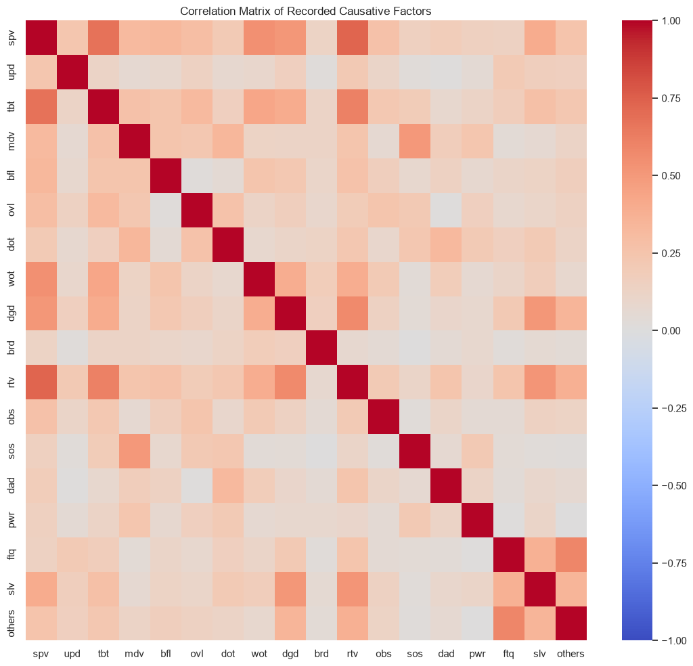
Figure B-1: Correlation Matrix of Recorded Road Traffic Accident Causative Factors

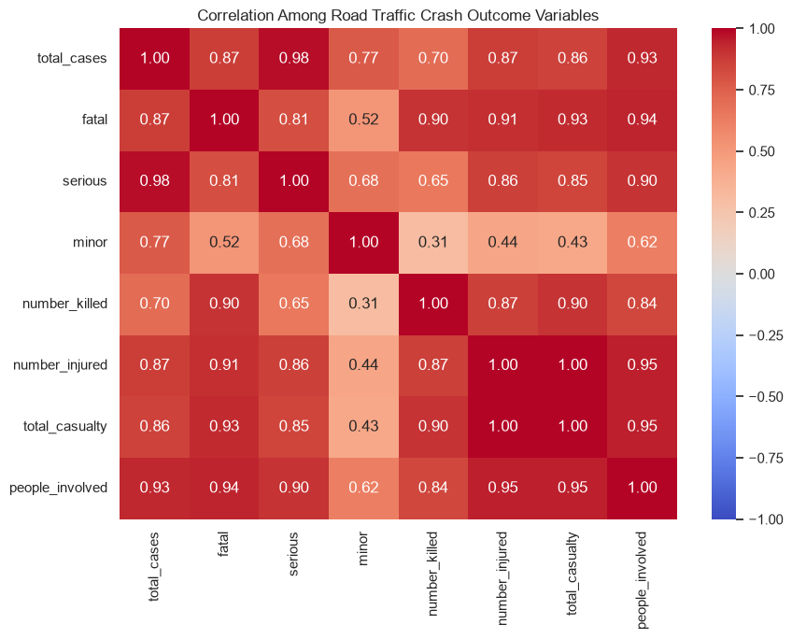
Figure B-2: Correlation Matrix of Road Traffic Crash Outcome Variables

  - Annual Forecasting Diagnostics
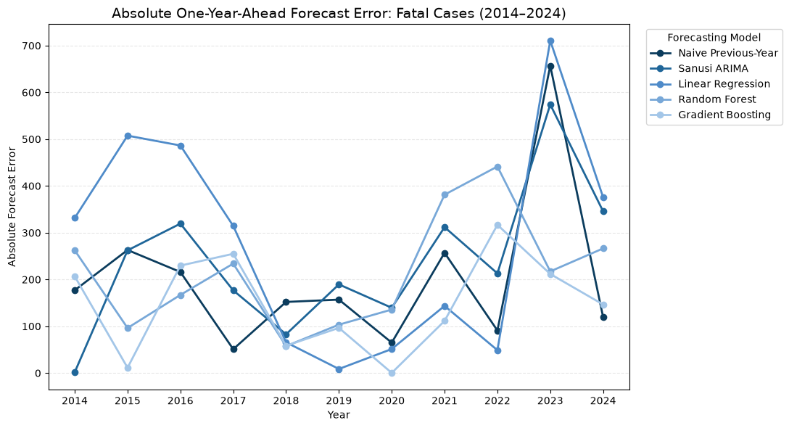
Figure C-1: Absolute One-Year-Ahead Forecast Errors for Fatal Road Traffic Crashes, 2014–2024
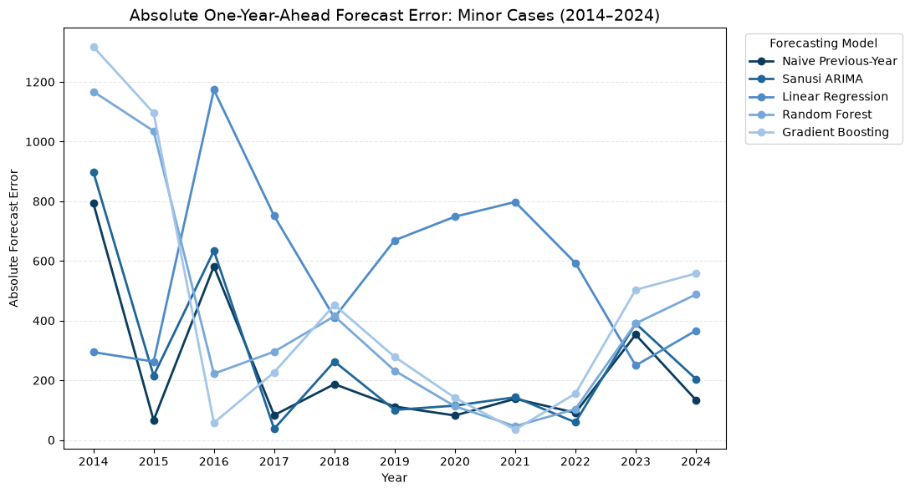
Figure C-2: Absolute One-Year-Ahead Forecast Errors for Minor Road Traffic Crashes, 2014–2024
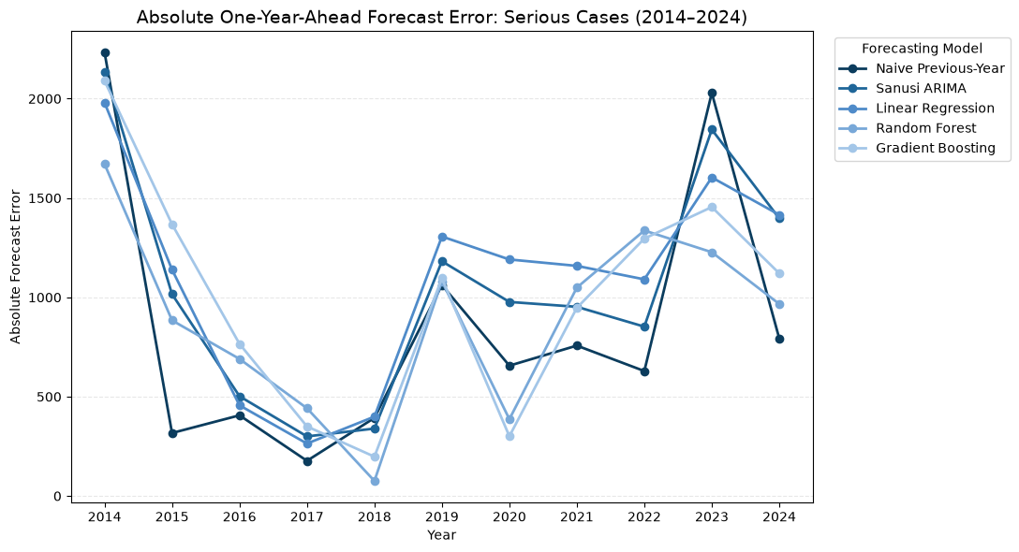
Figure C-3: Absolute One-Year-Ahead Forecast Errors for Serious Road Traffic Crashes, 2014–2024
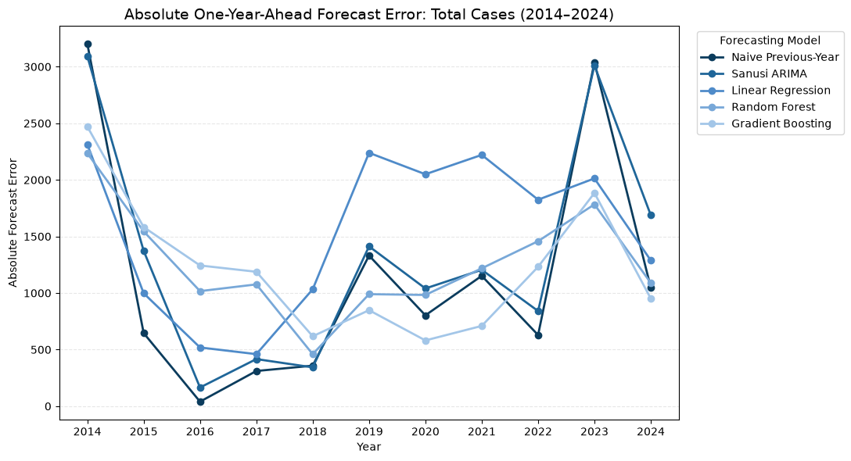
Figure C-4: Absolute One-Year-Ahead Forecast Errors for Total Road Traffic Crashes, 2014–2024

  - State-Quarter Forecasting Diagnostics

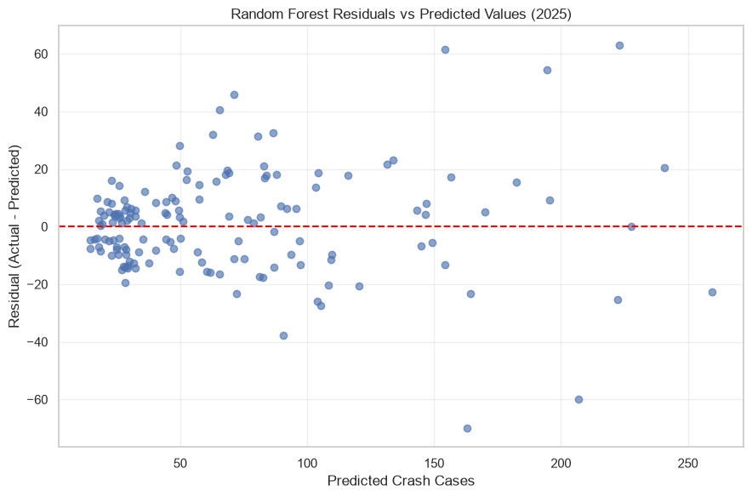
Figure D-1: Residuals versus Predicted Crash Counts for the Random Forest Model, 2025 Test Set

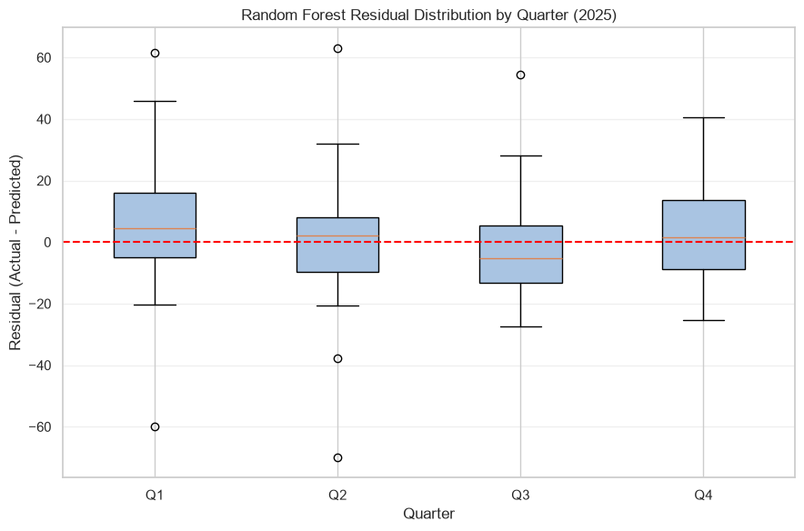
Figure D-2: Random Forest Residual Distribution by Quarter, 2025 Test Set

